**FOR INFORMATION CONTACT**

KIMBERLY PUPILLO

DIRECTOR – PUBLIC RELATIONS

MACK TRUCKS, INC.

336-662-1787

[Kimberly.pupillo@macktrucks.com](mailto:Kimberly.pupillo@macktrucks.com)

**MACK TRUCKS**

7900 NATIONAL SERVICE ROAD

GREENSBORO, NC 27409

MACKTRUCKS.COM

**FOR IMMEDIATE RELEASE**

NR# 23-25

**Mack Trucks Announces Two New Mack® MP®13 Engine Variants that it Expects will be Fully Compliant with CARB 2024 Omnibus Requirements**

**ANAHEIM, CA** (April 29, 2025) – Mack Trucks today announced that it is seeking certification of two new variants of the Mack® MP®13 engine that it expects will meet the California Air Resources Board (CARB) 2024 Omnibus requirements for low nitrogen oxide (NOx) and particulate matter (PM) emissions standards. Mack made the announcement during the Advanced Clean Transportation (ACT) Expo, April 28-May 1, at the Anaheim Convention Center, Anaheim, California.

The regulation requires a 75% reduction in NOx and 50% reduction in PM compared with existing U.S. Environmental Protection Agency (EPA) standards for engines in Class 8 highway trucks for engine model years 2024 through 2026. Once certified, the new MP13 CARB 2024 Omnibus-compliant engines, rated 425 horsepower and 1,750 lb.-ft. of torque or 455 horsepower and 1,850 lb.-ft. of torque, will be available in the recently launched Mack Pioneer™, Mack’s newest Class 8 on-highway vehicle.

“Mack will have a 13-liter engine that will be CARB 2024 Omnibus-compliant once certified, allowing Mack customers in California to have a fuel-efficient and more sustainable diesel engine to meet all of their highway application needs,” said Jonathan Randall, president of Mack Trucks North America. “At the same time that Mack is working to ensure its diesel customers have a durable, reliable highway truck, we also continue to invest and investigate other sustainable solutions, such as battery electric and hydrogen fuel cell power.”

A new 10kW heater was integrated into the EATS, as well as an additional battery box to support it. Both Mack MP13 engine variants feature the following engine-mounted components:

* A 48-volt alternator, required to support the heated exhaust aftertreatment system (EATS) and new battery components
* Specialized engine tuning software to support low NOx requirements

Once certified, the two variants of the Mack MP13 CARB 24-compliant engine will be available to order on Mack Pioneer models as soon as they’ve been certified. Mack expects that the certification process will be completed by the end of 2025. Fleets and owner-operators interested in the engines should contact their local Mack dealer.

**-more-**

***Page 2: Mack Trucks Announces Two New Mack® MP®13 Engine Variants that it Expects will be Fully Compliant with CARB 2024 Omnibus Requirements***

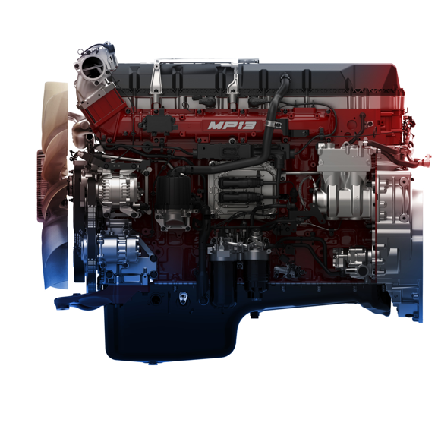**

**CAPTION:** Mack Trucks today announced that it is seeking certification of two new variants of the Mack® MP®13 engine that it expects will meet the California Air Resources Board (CARB) 2024 Omnibus requirements for low nitrogen oxide (NOx) and particulate matter (PM) emissions standards. Mack made the announcement during the Advanced Clean Transportation (ACT) Expo, April 28-May 1, at the Anaheim Convention Center, Anaheim, California.

***NOTE TO EDITORS:  These photos can be viewed and downloaded at*** [***https://press.macktrucks.com***](https://eur02.safelinks.protection.outlook.com/?url=https%3A%2F%2Fpress.macktrucks.com%2F&data=05%7C01%7Ckimberly.pupillo%40macktrucks.com%7C3d76022c9c1346ce51b108db1ff589b7%7Cf25493ae1c9841d78a330be75f5fe603%7C0%7C0%7C638138911668663318%7CUnknown%7CTWFpbGZsb3d8eyJWIjoiMC4wLjAwMDAiLCJQIjoiV2luMzIiLCJBTiI6Ik1haWwiLCJXVCI6Mn0%3D%7C3000%7C%7C%7C&sdata=%2BVT4H8Z32bE68IPwi2X7oyQvNYogxvlX6BSHjkV5nE4%3D&reserved=0)***.***

Dedicated to durability, reliability and meeting the needs of customers, Mack

Trucks has provided purpose-built transportation solutions for 125 years. Today, Mack is one of North America’s largest producers of heavy-duty trucks, and Mack® trucks are sold and serviced through an extensive distribution network in more than 45 countries. Mack trucks, diesel engines and transmissions sold in North America are assembled in

the United States. Mack manufacturing locations are certified to the internationally recognized ISO 9001 standard for quality, ISO 14001 standard for environmental management systems and ISO 45001 standard for health and safety management systems. Mack is also a proud sponsor of Share the Road, an American Trucking Associations public information campaign aimed at enhancing the safety of our

nation's roadways.

Mack Trucks is part of the Volvo Group, which is driving prosperity through

transport and infrastructure solutions, offering trucks, buses, construction equipment,

power solutions for marine and industrial applications, financing and services that

increase customer uptime and productivity. Founded in 1927, the Volvo Group is

committed to shaping the future landscape of sustainable transport and infrastructure solutions. The Volvo Group is headquartered in Gothenburg, Sweden, employs about 104,000 people and serves customers in almost 190 markets. In 2024, net sales amounted to about $50 billion. For more information, please visit [www.volvogroup.com](https://eur02.safelinks.protection.outlook.com/?url=http%3A%2F%2Fwww.volvogroup.com%2F&data=05%7C02%7Ckimberly.pupillo%40macktrucks.com%7Cc393f43385624515b47608dd550a86be%7Cf25493ae1c9841d78a330be75f5fe603%7C0%7C0%7C638760226229333704%7CUnknown%7CTWFpbGZsb3d8eyJFbXB0eU1hcGkiOnRydWUsIlYiOiIwLjAuMDAwMCIsIlAiOiJXaW4zMiIsIkFOIjoiTWFpbCIsIldUIjoyfQ%3D%3D%7C0%7C%7C%7C&sdata=VzvflzngoLMdU%2FH6iUuDnVU0ZBOEttNWQEH8WzviMEc%3D&reserved=0).

***For more information about Mack, visit our website at*** [***www.macktrucks.com***](http://www.macktrucks.com)

# # #