

PRESS RELEASE

Blue Bird Debuts Electric Step Van at 2024 Advanced Clean Transportation (ACT) Expo
Company Teams Up With Xos and Morgan Olson to Build Commercial Vehicle Prototype on Class 5-6 Stripped Chassis

MACON, Ga. (May 20, 2024) – Blue Bird Corporation (Nasdaq: BLBD), the leader in electric and low-emission school buses, will debut its electric-powered step van at the upcoming 2024 Advanced Clean Transportation (ACT) Expo, North America’s largest advanced transportation technology and clean fleet event. The company teamed up with Xos (Nasdaq: XOS) and Morgan Olson to manufacture the prototype. Blue Bird will showcase its groundbreaking zero-emission vehicle and underlying stripped chassis at the trade event from May 20-23, 2024, at the Las Vegas Convention Center, booth 2470, in Las Vegas, Nev.

Blue Bird builds on its nearly century-long expertise in school bus manufacturing to expand its zero-emission transportation solutions to the commercial vehicle market. The last-mile delivery step van and stripped chassis on display feature a 140kWh Lithium-ion battery. The batteries are mounted inside the frame rails for superior battery protection. The battery pack supports a vehicle range of up to 130 miles on a single charge. It takes between one and twelve hours to fully recharge depending on the charging infrastructure.

Blue Bird’s prototype is based on a 178” wheelbase for last-mile-delivery vehicles with a gross vehicle weight rating (GVWR) of up to 23,000 pounds. The company utilizes lightweight materials and components for its innovative vehicle platform maximizing vehicle payload while continuing to prioritize vehicle safety.

Blue Bird offers several safety features on its EV prototype not standard on comparable electric vehicles to enhance driver protection and familiarity. This includes “hill hold,” which prevents the vehicle from rolling backward or forward when sitting stationary on a hill, and “electric creep,” which allows the vehicle to slowly start moving from a stop when the driver's foot is removed from the brake pedal to simulate a gasoline engine in gear. In addition, the Blue Bird stripped chassis provides 55-degree, best-in-class wheel cut to improve maneuverability in tight urban settings.

“In 2022, Blue Bird introduced its EV commercial chassis concept vehicle at ACT Expo,” said Britton Smith, president of Blue Bird Corporation. “This week, we will debut the operating prototype of our electric-powered step van at the 2024 ACT Expo that’s based on industry-leading EV technology. For nearly a century, Blue Bird has perfected its core capabilities of designing, engineering and manufacturing school buses from the ground up. Now we are one step closer to applying our world-class vehicle manufacturing expertise and expanding our electric-powered product range to the commercial vehicle market.”

Blue Bird has partnered with Xos, a leading electric truck manufacturer and fleet electrification services provider from California, offering their expertise gained from deploying hundreds of zero-emissions commercial electric vehicles since 2018. The powertrain technology from Xos is a key feature in Blue Bird's step van. Additionally, this collaboration includes Morgan Olson, a Michigan-based builder of work truck bodies, which is responsible for providing the body for the prototype. Morgan Olson’s work truck bodies deliver millions of parcels to businesses and homes in North America every day.

"We are honored that Blue Bird has chosen to entrust Xos with the technology to power its electric step van prototype,” said Dakota Semler, CEO of Xos. “This collaboration is a testament to the reliability, efficiency, and innovation that Xos brings to the forefront of the commercial electric vehicle market."

"We at Morgan Olson are looking forward to a productive collaboration with Blue Bird and Xos on the development of this step van prototype," said Mike Ownbey, president and CEO of Morgan Olson. "By combining the expertise of our industry-leading companies, we are confident that we can offer our existing and new step van customers a new chassis option that provides great value in the commercial vehicle market."

Blue Bird anticipates for its electric-powered stripped chassis to be commercially available in late 2024. The company is the only U.S.-owned and operated school bus manufacturer in the United States. In addition, Blue Bird is the number one builder of electric school buses in North America with more than 1,500 zero-emission school buses in operation today.

Blue Bird will also feature its latest low- and zero-emission vehicle technologies at ACT Expo. The company remains the proven clean transportation leader with more than 20,000 propane, natural gas, and electric-powered buses in operation today. ACT Expo takes place from May 20-23, 2024, at the Las Vegas Convention Center in Las Vegas, Nev.

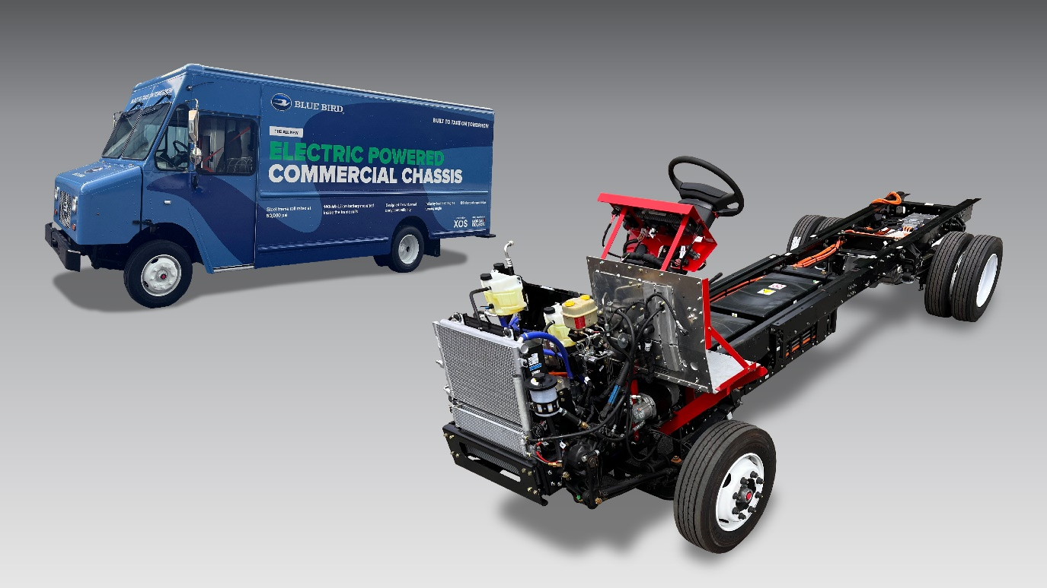
Press Photo/Caption: Blue Bird will debut the operating prototype of an electric-powered step van and underlying stripped chassis at the 2024 Advanced Clean Transportation (ACT) Expo on May 20-23, 2024, at the Las Vegas Convention Center. Blue Bird teamed up with Xos and Morgan Olson to build the prototype of the groundbreaking last-mile delivery commercial vehicle. (Image provided by Blue Bird Corporation)

About Blue Bird Corporation
Blue Bird (NASDAQ: BLBD) is recognized as a technology leader and innovator of school buses since its founding in 1927. Our dedicated team members design, engineer and manufacture school buses with a singular focus on safety, reliability, and durability. School buses carry the most precious cargo in the world – 25 million children twice a day – making them the most trusted mode of student transportation. The company is the proven leader in low- and zero-emission school buses with more than 20,000 propane, natural gas, and electric powered buses in operation today. Blue Bird is transforming the student transportation industry through cleaner energy solutions. For more information on Blue Bird's complete product and service portfolio, visit www.blue-bird.com.

About Xos, Inc.
Xos is a leading technology company, electric truck manufacturer, and fleet services provider for battery-electric fleets. Xos vehicles and fleet management software are purpose-built for medium- and heavy-duty commercial vehicles that travel on last-mile, back-to-base routes. The company leverages its proprietary technologies to provide commercial fleets with battery-electric vehicles that are easier to maintain and more cost-efficient on a total cost of ownership (TCO) basis than their internal combustion engine counterparts. For more information, visit www.xostrucks.com.

About Morgan Olson
Morgan Olson is North America's leading walk-in step van body manufacturer, with a portfolio of customers serving many industries and delivery applications. The primary sector these iconic work truck step vans serve is parcel package pick up & home delivery. Almost everything ordered online is delivered daily by a Morgan Olson Walk-In Step Van to millions of businesses and homes. Other vital industries served include uniform rental and commercial laundry services, baking and snack foods, city municipalities, telecommunications providers, utility services, and mobile cuisine food trucks. For more information, visit https://morganolson.com.

Media Contact
Julianne Barclay
TSN Communications
M: +1.267.934.5340
E: julianne@tsncommunications.com

