**Electric Truck Company Harbinger Announces $400 Million in Customer Vehicle Orders from Bimbo Bakeries USA, RV Manufacturer THOR Industries, Nationwide Dealers and More**

* 4,000 binding pre-orders from customers including [Bimbo Bakeries USA](https://bimbobakeriesusa.com/); the world’s largest RV manufacturer, [THOR Industries](https://www.thorindustries.com/); postal service operator, [Mail Management Services](https://mailmanagementservices.com); leading North American commercial vehicle dealers; and more.
* Harbinger formally announces it raised one of the hardware industry’s largest-ever Series A rounds, which closed at $73 million in Q4 2023.
* The company announces its North American network of premier dealers, which is already positioned to serve 78% of the population in the U.S. and Canada, and continues to grow.
* The new orders and funds are catalyzing rapid growth around the manufacturing and commercialization of Harbinger’s innovative electric vehicle chassis.

**LAS VEGAS / LOS ANGELES, May 21, 2024** -- [Harbinger](http://www.harbingermotors.com), a Southern California-based electric truck manufacturer, announced today at [ACT Expo](https://www.actexpo.com) its order book, which includes 4,000 binding vehicle pre-orders from customers and is valued at more than $400 million. This includes a substantial multi-year order from [Bimbo Bakeries USA](https://bimbobakeriesusa.com/), the U.S. business of [Grupo Bimbo](https://www.grupobimbo.com/en/home), the world’s largest baking company, and producer of iconic brands including Sara Lee Bread®, Thomas’®, Entenmann's® and more. Harbinger also received orders from the world’s largest recreational vehicle (RV) manufacturer, [THOR Industries](https://www.thorindustries.com/), known for its operating companies which include Airstream, Jayco, Tiffin and Thor Motor Coach. Additionally, commercial vehicle dealers have placed significant orders including two of Freightliner’s largest dealers [Doggett Equipment Services Group](https://www.doggett.com/) (500 units) and [Campbell Supply](https://www.campbellsupply.com/) (125 units); as well as other dealers, [GATR Truck Center](https://www.gatr.net) (500 units); [ETHERO Truck + Energy](https://ethero.com/) (200 units); Electric Commercial Vehicles (ECV), an affiliate of [Smyrna Truck](https://smyrnatruck.com) (50 units) and more. Postal service operator, [Mail Management Services](https://mailmanagementservices.com) has also placed an order for 40 units, among others.

The company has also announced it closed an additional $13 million in Series A funds in Q4 of 2023 from venture and strategic investors, including additional funding from the [Coca-Cola System Sustainability Fund](https://www.coca-colacompany.com/media-center/company-and-bottling-partners-announce-creation-sustainability-focused-venture-capital-fund-partnership-with-greycroft), managed by [Greycroft](https://www.greycroft.com). Previously, the company [announced](https://www.prnewswire.com/news-releases/harbinger-motors-gains-broad-investor-support-in-60m-series-a-funding-301932869.html) it had raised $60 million in Series A funds, bringing the new Series A total to $73 million and marking one of the largest Series A rounds for a hardware company. Harbinger will use the additional funds to continue expanding its manufacturing capacity and launch its commercial start of production in Q4 of 2024.

“While other new entrants struggle to fill their order pipelines, we have extensive pre-orders and backed-up demand for our medium-duty electric vehicles,” said John Harris, CEO, Harbinger. “We are laser focused on the medium-duty vehicle segment, where there is a huge variety of vehicles built on chassis like ours including walk-in vans, box trucks, recreational vehicles, delivery vans, school buses, emergency and disaster response vehicles and more. Today, most manufacturers are adapting gasoline or diesel vehicles to electrification, rather than building a ground-up electric platform. This compromised approach leads to concerns with vehicle safety and durability as well as higher production costs, which is why we chose to start fresh with a clean sheet design.”

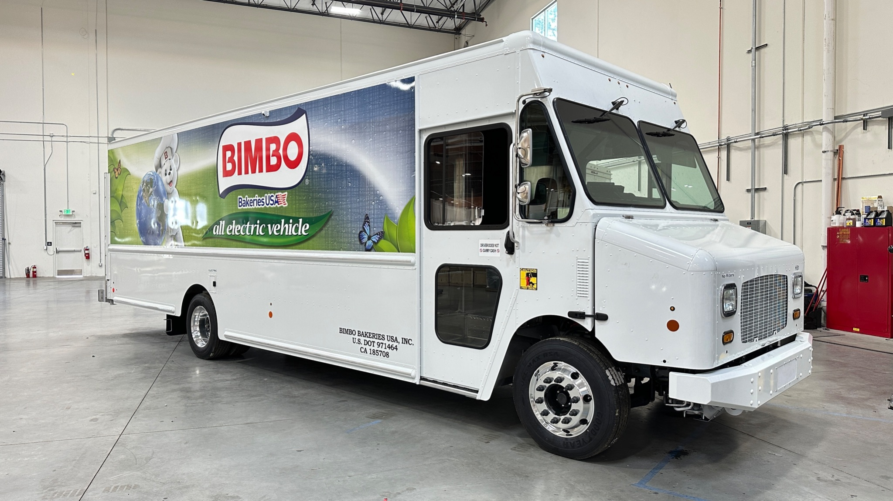

A Harbinger medium-duty electric walk-in van. Walk-in vans are also commonly referred to as “step vans.”

**A Premier Network of Partners and Dealers**

Part of Harbinger’s strategy is to build a holistic network to support the launch of its electric medium-duty trucks, including a nationwide network of service providers, charging and infrastructure development partners, and premier dealers. The company’s premier dealer network, which already serves 78% of the population in the U.S. and Canada and continues to expand, includes the following among others:

* [Campbell Supply](https://www.campbellsupply.com/)
* [Doggett Equipment Services Group](https://www.doggett.com/)
* [EBY Ford](https://www.ebyford.com)
* [ETHERO Truck + Energy](https://ethero.com/)
* [EV Choice](https://www.evchoice.com)
* GATR EV, a division of [GATR Truck Center](https://www.gatr.net)
* [Hendrickson Fire](https://hendricksonfire.com)
* Electric Commercial Vehicles (ECV), an affiliate of [Smyrna Truck](https://smyrnatruck.com)
* [Safetek Specialty Vehicles](https://firetrucks.ca) (Canada)

“Demand outstrips supply for the entire medium-duty category as we have a multi-year backlog for electric, diesel and gasoline vehicles,” said Scott Campbell, Owner, Campbell Supply. “Electric vehicles have a big place in the market and that segment is only going to continue to grow. Harbinger’s electric trucks are a true industry changer. They offer superior acquisition and operating costs, enhanced safety features, and a driver-friendly design, all while delivering zero tailpipe emissions.”

**Seasoned Team, Clean Slate Design**

Harbinger is led by a management and technical team that hails from Tesla, Rivian, Ford, Anduril, SpaceX, Toyota, Honda, Volvo Trucks, Mack Trucks, and more. Harbinger has created a proprietary electric platform, also known as an electric vehicle stripped chassis, from the ground-up. It includes all major vehicle systems, which the company designs and assembles in house, including the powertrain, high voltage (HV) battery system, steering, brakes, and more. This vertically integrated approach keeps costs low and provides a higher-performing, safer and more durable solution than electric vehicles built upon existing diesel and gasoline platforms, which is common in the industry. Harbinger is the only electric truck maker that manufactures its own motors and battery packs, which is a more cost effective and tailored solution than integrating off-the-shelf systems.

**Harbinger Business Model**

Once Harbinger assembles its electric vehicle stripped chassis, the company sells them to a dealer, a specialty upfitter, or directly to large fleet customers. From there, the dealer or customer works with a third party to upfit the chassis with a commercial or specialty body. Selling medium-duty stripped chassis separately from the body is standard practice for the large gas and diesel incumbents such as Ford and Freightliner.

Harbinger’s ground-up designed proprietary electric platform, also known as an electric vehicle stripped chassis.

**One Platform, Many Possibilities**

The majority of the vehicles in Harbinger’s 4,000-unit order, including those for Bimbo Bakeries USA, are intended for upfit into walk-in vans, which are commonly referred to as “step vans” and are the typical large package delivery trucks seen on roads today. The others will be upfit into various vehicle types such as class A motorhomes, emergency vehicles and cutaway cabs, which are vehicles where only a cab is provided and an upfitter provides a custom-built payload area to create box trucks, shuttle buses, and more. Harbinger is working with body partner Sevna to upfit the chassis into cutaway cabs. Harbinger’s electric chassis is available in three different wheelbases, including 158 inches, 178 inches, and 208 inches, and in four different gross vehicle weight ratings (GVWRs), ranging from class 4 through 6.

Other specifications include:

* 800V liquid cooled battery system, with capacity scalable in 35kWh increments up to a 200+ mile range, which [serves 90% of truck use cases](https://ops.fhwa.dot.gov/freight/freight_analysis/nat_freight_stats/docs/10factsfigures/table3_6.htm)
* Designed for 20-year, 450,000-mile service life
* Segment-leading safety and driver assistance features
* One-hour DC fast charging capability
* Passenger vehicle-like handling and ride comfort

“Aligned with Grupo Bimbo’s Purpose of Nourishing a Better World, Bimbo Bakeries USA has multiple carbon reduction strategies to meet their commitment of achieving Net-Zero emissions by 2050,” said [Christopher Wolfe](https://www.linkedin.com/in/wolfechristopher/), Senior Director of Sustainability, Bimbo Bakeries USA. “Partnering with Harbinger to expand our robust fleet of alternatively fueled vehicles is an important step in reducing our carbon emissions and dependencies on fossil fuels.”

**Early Orders Being Manufactured Today**

Harbinger’s manufacturing efforts are led by a world-class team including Tesla’s former Vice President (VP) of Manufacturing, [Gilbert Passin](https://www.prnewswire.com/news-releases/harbinger-names-former-tesla-manufacturing-vp-gilbert-passin-as-chief-production-officer-301691002.html), who serves as Harbinger’s Chief Production Officer. Passin, who spent nearly a decade at Tesla and led the launch and ramp-up of the Tesla Fremont factory, also held prior VP and General Manager-level roles with Toyota, Volvo Trucks, Mack Trucks, and Renault. Former Rivian VP of Supply Chain and Tesla executive [Steve Gawronski](https://www.prnewswire.com/news-releases/harbinger-hires-former-rivian-tesla-operating-executive-steve-gawronski-as-vice-president-supply-chain-and-logistics-302076716.html) serves as Harbinger’s Vice President of Supply Chain and Logistics.

Under Passin and his team’s leadership, the company has already produced and delivered a limited number of pre-production vehicles to key customers, including the [first customer delivery to THOR](https://www.prnewswire.com/news-releases/harbinger-motors-delivers-first-electric-chassis-to-thor-industries-302087426.html) in March of this year. Harbinger will begin producing and delivering its first production vehicles starting at the end of 2024.

"The THOR executives were amazed by the clean design of Harbinger’s electric chassis, and most had a hard time believing this was a pre-production vehicle,” said [Jim Kane](https://www.linkedin.com/in/jekane/), Director of eMobility at THOR Industries. “Harbinger’s product is so much better than anything else we have seen from the industry."

**Government Incentives are a Game Changer for the Industry**

Government regulations are accelerating the adoption of electric vehicles into fleets across the nation. The U.S. federal government’s Inflation Reduction Act (IRA) is providing up to $40,000 per vehicle in tax incentives to buyers or lessors of commercial electric vehicles; either 30% of the original purchase price of the vehicle minus the credit, or the price difference between the electric vehicle and an equivalent gas or diesel vehicle. This incentive is valid from Jan. 1, 2023 through Dec. 31, 2032 with no limit on the number of vehicles sold or amount of money disbursed through this incentive. Additionally, state and local zero-emissions grants introduce substantially more cost savings directly to customers. For example, [California’s Hybrid and Zero-Emissions Truck and Bus Voucher Incentive Project](https://californiahvip.org) (HVIP) provides buyers with approximately $30,000 - $85,000 worth of grants to purchase clean vehicles.

“Harbinger was founded on the principle that for commercial electric vehicles to become ubiquitous, they should be just as affordable to purchase as their gas and diesel counterparts,” said Harris. “The medium-duty truck market will quickly move to clean, economical electric power over the next few years, especially as government tax incentives and grants make all-electric trucks more affordable. There is a huge need for electrification in this market, and Harbinger is filling that gap.”

**Price Parity with Gasoline and Diesel Vehicles**

Most electric vehicles are only cost competitive with gasoline and diesel vehicles when factoring in the total cost of ownership, which takes into account the fuel and maintenance savings over many years. Harbinger takes a different approach. The company’s vehicles are sold at price parity with equivalent gas and diesel models after federal government tax incentives.

**Harbinger at ACT Expo**

Harbinger is exhibiting at this year’s [Advanced Clean Transportation (ACT) Expo](https://www.actexpo.com/agenda/). With one of the largest booths (#1271), they are showcasing a Bimbo Bakeries USA walk-in van, a cutaway cab developed by Harbinger partner Sevna, and the full suite of Harbinger’s proprietary vehicle technologies, including a complete electric stripped chassis and advanced safety systems demonstrations. On Wed., May 20 at 2:15 p.m. PT, Harbinger CEO John Harris will speak on a panel titled [Vehicle Innovation](https://www.actexpo.com/agenda/#day-05-22-2024), where he will discuss transformative innovations in vehicle technology for fleet applications. The expo floor opened on Mon., May 20, in Las Vegas, Nevada and ends on Thurs., May 23.

**About Harbinger**

Harbinger is a commercial electric vehicle (EV) company on a mission to transform an industry starving for innovation. Harbinger's best-in-class team of EV, battery, and drivetrain experts have pooled their deep experience to support the growing demand for medium-duty EVs. Leveraging a foundation of proprietary, in-house developed vehicle technologies designed specifically for commercial and specialty vehicle applications, Harbinger is bringing a first-of-its-kind EV platform to market, priced at parity to gasoline and diesel vehicles. *Harbinger: familiar form, revolutionary foundation.*

To learn more about Harbinger, please visit [www.harbingermotors.com](https://harbingermotors.com/).

**###**

**Harbinger Media Contact**

Kylee Keskerian

PR Manager

419-822-6417

[kylee@futuristacommunications.com](mailto:kylee@futuristacommunications.com)