P R E S S R E L E A S E

Volvo Autonomous Solutions Showcases Volvo VNL Autonomous and Outlines Plans for Industrialization and Lane Expansion
Volvo Autonomous Solutions (V.A.S.) is transforming the movement of goods with safe, efficient autonomous solutions—operating today on highways and in mining and quarrying operations globally. The Volvo booth (#4537) at the Advanced Clean Transportation (ACT) Expo, held at the Anaheim Convention Center from April 28 to May 1, 2025, will showcase the Volvo VNL Autonomous—a fully redundant autonomous truck designed for commercial scalability and integration with various self-driving technologies.
Scaling Autonomy: Production at Volvo's Largest North American Truck Plant
The Volvo VNL Autonomous is built on the platform of the all-new Volvo VNL and launched in April 2024. It is purpose designed for autonomy and integration with multiple partner-developed autonomous driver technologies, supporting diverse operational needs, use cases, and Volvo Group truck brands. Production will ramp up at Volvo’s New River Valley plant in Dublin, Virginia, leveraging the site’s decades of manufacturing experience. Built from the ground up with redundancies for critical systems, the Volvo VNL Autonomous features dual braking, steering, communication, computing, power and energy storage, and motion control. Volvo intentionally duplicated safety-critical components and even lights and hazard signals, for safe operations in the event of component failure.
Partnering to Lead: Updates on Aurora and New Collaboration with Waabi
V.A.S. has been partnering with self-driving pioneer Aurora Innovation since 2018 to develop and commercialize on-highway autonomous Class 8 trucks. The companies are integrating the Aurora Driver in the Volvo VNL Autonomous, and reached a new milestone in 2024, with autonomous freight being hauled in Texas with a safety driver — demonstrating tangible progress and industry leadership. A Volvo VNL Autonomous integrated with the Aurora Driver will also be on display in the Aurora Innovation booth (#5421) at ACT Expo demonstrating the strength of the partnership.
As the next step in its multi-partner strategy, V.A.S. announced a new collaboration with Waabi, a leader in generative AI technology for autonomous driving. Waabi’s virtual driver, the Waabi Driver, will be integrated into the Volvo VNL Autonomous, ultimately leading to the deployment of autonomous trucks operating on US highways.
“At Volvo, we leverage our deep expertise in autonomy-enabled trucks by partnering strategically with technology leaders such as Aurora and Waabi. Our partners share our commitment to safety, innovation, and excellence,” said Nils Jaeger, president of V.A.S. “Our experience developing our own virtual driver for mining applications has shown us that partnering is essential for more complex environments, like public road applications. These partnerships enable us to accelerate and jointly deliver safer, more efficient, and scalable autonomous transport solutions to the US economy.”
Inside the Autonomous Ecosystem – The Critical Components for Real-World Deployment
In addition to autonomy-enabled trucks, V.A.S. is also developing a cohesive ecosystem that is essential for autonomous transport solutions. This comprehensive framework encompasses critical uptime services, robust fleet management systems, optimized terminal operations, and dedicated operational support specifically designed for autonomous deployment at scale. The ecosystem is further strengthened by the extensive service and maintenance network of Volvo Trucks dealerships. This integrated approach allows V.A.S. to offer Autona/Freight, a comprehensive solution based on Transport as a Service (TaaS), simplifying the transition to autonomy for customers by leveraging the new ecosystem's capabilities with V.A.S. as the single point of contact.
On the Road Today in Texas
V.A.S. is already on the road today from Dallas to Houston, hauling goods autonomously with a safety driver for DHL Supply Chain and Uber Freight. This initiative highlights the tangible progress being made in real-world conditions, and V.A.S. has plans to further expand the lanes to cover the Sunbelt and eventually the whole of the United States. Collaborations with customers such as DHL are instrumental in achieving V.A.S.'s final milestone—removing the safety driver and delivering on the promise of autonomy for a safer, more efficient future.
To learn more about Volvo Autonomous Solutions, visit the company website.
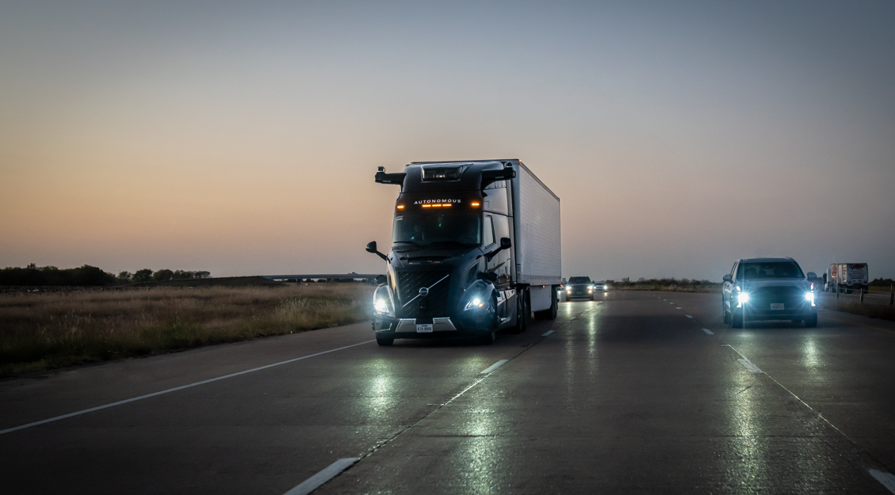
CAPTION: A Volvo VNL Autonomous, integrated with the Aurora Driver will be showcased in the Volvo booth #4537 at ACT Expo in Anaheim, California, April 28-May 1, 2025.
High-resolution images associated with this press release and others are available at https://www.volvoautonomoussolutions.com/en-en/news/media-gallery.html.
About Volvo Autonomous Solutions
The autonomous transport solution offered by Volvo Autonomous Solutions includes a vehicle purpose-built for autonomous driving, a virtual driver, required infrastructure, operations and uptime support as well as a cloud solution that controls the transport system and manages logistics flows. The solutions developed by Volvo Autonomous Solutions are tailor-made for each customer's needs are intended to make their operations safer, and more productive and sustainable.
Media Contact
Ceren Wende
Head of Marketing and Communication, Volvo Autonomous Solutions
Phone: + 46 31 322 4536
E-mail: ceren.wende@volvo.com

