P R E S S I N F O

# VOLVO CE AND PARTNERS ANNOUNCE NEW MOBILE CHARGING SOLUTIONS FOR ELECTRIC EQUIPMENT

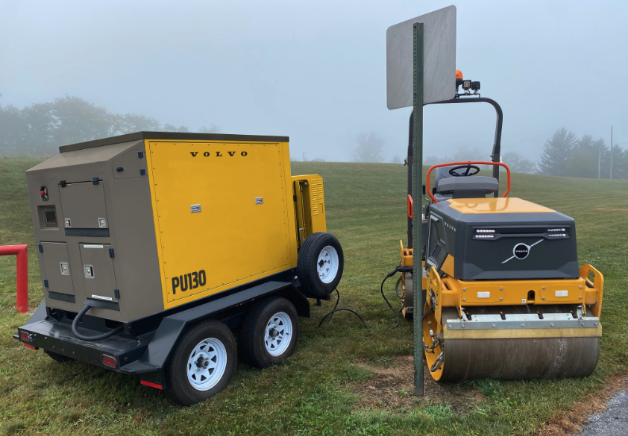

**The PU130 is a power unit that resulted from a collaboration between Volvo CE and Portable Electric.**

Volvo Construction Equipment, Volvo Penta and two leading manufacturers of charging solutions launched two new products in the North American market this week at the Advanced Clean Transportation (ACT) Expo in Las Vegas.

At a press event on Monday, Volvo CE unveiled two Volvo-branded mobile charging units called the PU750 and the PU130, marking the latest collaboration of industry pioneers. The PU750 power unit is ideal for fast-charging larger equipment on-site without needing a converter, while the PU130 is a portable DC fast charging unit for compact machines.

“We all have a common goal to revolutionize the landscape of sustainable technology within the heavy equipment sector,” said Dr. Ray Gallant, vice president — sustainability and productivity services at Volvo CE. “Collaborating on these products allows us to make significant steps forward in the adoptability of electric machines.”

**The PU750**

Developed and built by [Utility Innovation Group](https://utilityinnovation.com/) (UIG) in close cooperation with Volvo CE and Volvo Penta, the PU750 leverages the Volvo Group CAST (Common Architecture, Shared Technology) strategy. The partnership applies Volvo Penta’s leading battery sub-system to support charging around the world and allows mid-size electric machines to charge on a variety of jobsites thanks to its adaptability to multiple infrastructure setups and easy transport.

“It’s not always clear what power availability you will have for charging on a jobsite, but this solution has been strategically developed to put our microgrid integration and GridSure expertise to work in order to dynamically adapt to all utility and on-site generation conditions,” said Derek Tugwell, president of UIG. “We’re really excited about how this solution will drive adoption of electrified off-road equipment and help drive decarbonization.”

The first-generation PU750 has enough energy to support three to four mid-size machines like the Volvo [EC230 Electric excavator](https://www.volvoce.com/united-states/en-us/products/electric-machines/ec230-next-level/) through twin CCS1 connections before the 792 kWh Volvo-based batteries need to be recharged. When used with the grid interactive UIG power system, the PU750 can seamlessly maximize available AC power and integrate on-site distributed energy assets to enable vehicle charging operations. Multiple assets can be tracked, managed and visualized within the GridSureTM platform, making vehicle and charging power management clear. The PU750 also integrates solar panels to aid in controls and auxiliary system support when it is away from the grid, and its rugged design makes it a solid choice for tough environments.

“We [teamed up](https://www.volvopenta.com/en-us/about-us/news-page/2023/mar/volvo-penta-and-uig-partner-to-support-grids-with-bess/) with UIG last year because of their expertise in integrating multiple assets to maximize on- and off-grid charging possibilities,” said Darren Tasker, vice president industrial, Volvo Penta North America. “Weaving our Volvo CE teammates into the partnership was always the plan, and it’s exciting to see what has come of this relationship so quickly.”

**The PU130**

Based on [Portable Electric](https://portable-electric.com/)’s proprietary 48-volt direct current fast charging (DCFC) technology, the PU130 provides the ability to charge compact equipment in less than an hour with 130 kWh of energy storage capacity and a 20 kW charge rate. In addition to charging equipment, the PU130 can simultaneously provide 40 kW of site power.

"We are incredibly proud to partner with Volvo CE in bringing the PU130 to market,” said Keith Marett, CEO of Portable Electric. “This first-of-its-kind unit is a testament to our shared dedication and the importance of collaboration to reduce the use of carbon-intensive fuels at construction sites.”

The PU130 will be available through the North American Volvo dealer network later this year.

**Teaming up to move ahead**

While these are not Volvo CE’s first — or last — power unit collaborations, they are further proof of the OEM’s commitment to providing the best solutions possible to make carbon reduction in the construction industry a reality.

“Battery-electric equipment is not feasible for every jobsite or application, but its use cases continue to grow,” said Gallant. “As long as owners and operators are making an effort to reduce emissions in whatever way they can, that is forward progress.”

Gallant also shared pilot test results at the event, demonstrating the initial success and ongoing learning around the electrification of larger machines.

Learn more about charging electric construction equipment at [volvoce.com/united-states/en-us/products/electric-machines/electric-construction-equipment/charging](http://www.volvoce.com/united-states/en-us/products/electric-machines/electric-construction-equipment/charging).

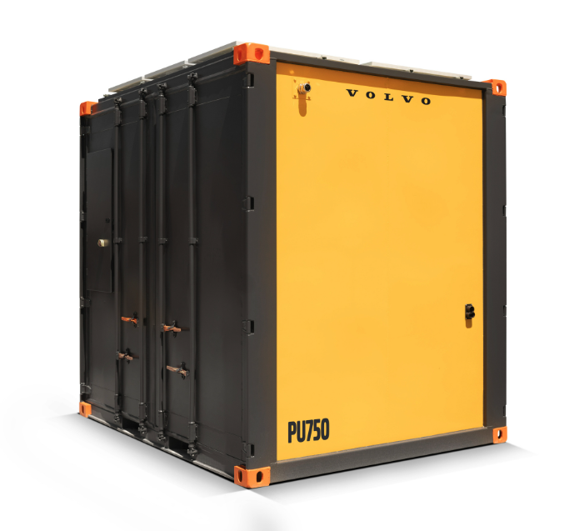

Volvo PU750 Quick Specs:

* DC fast vehicle charging: 500 kW
* Storage capacity: 793 kWh
* AC recharging: 480 kW
* AC voltage support: 400 V – 38 kV
* AC frequency: 50 – 60 Hz
* CCS1 or CCS2 charging connectors
* GridSureTM microgrid control, management and data enablement

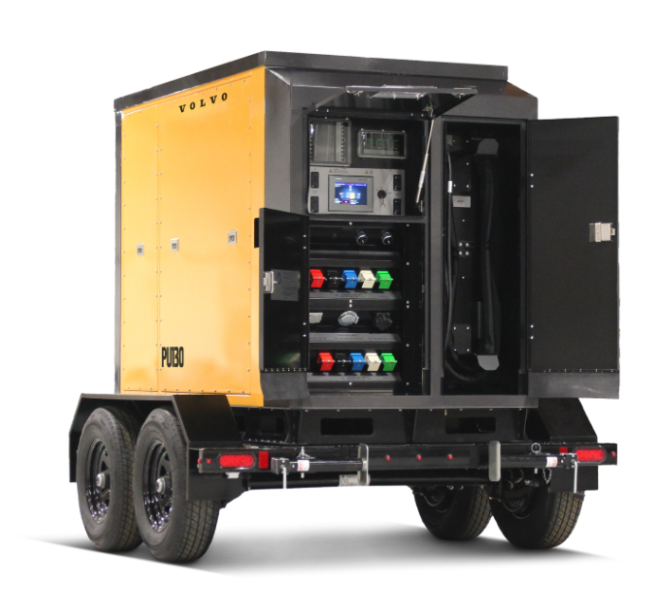

Volvo PU130 Quick Specs:

* AC output: 40 kW
* Low voltage DC fast charging: 20 kW
* Storage capacity: 130 kWh
* Neuron OS enabled wireless monitoring platform for real-time data, analytics and GPS

May 21, 2024

*Journalists wanting further information, please contact:*

*Gregg Hennigan Dave Foster*

*Marketing Communications Corporate Communications*

*Volvo Construction Equipment North America Volvo Construction Equipment North America*

*greggh@2rm.com dave.foster@volvo.com*

*515-557-2233 717-300-6104*

For more information, please visit [www.volvoce.com](http://www.volvoce.com).

For frequent updates, follow us on

X: [@VolvoCE_NA](https://twitter.com/VolvoCE_NA)

LinkedIn: [Volvo Construction Equipment](https://www.linkedin.com/company/volvo-construction-equipment/)

Facebook: [@VolvoCENA](https://www.facebook.com/volvocena)

Instagram: [@VolvoCE_NA](https://www.instagram.com/volvoce_na/)

YouTube: [Volvo Construction Equipment – North America](https://www.youtube.com/user/volvocena)

**About Volvo Construction Equipment:**

Volvo CE is a leading international manufacturer of premium construction equipment, and with over 15,000 employees, it is one of the largest companies in the industry. Volvo CE offers a wide range of products and services in more than 140 countries through its global distribution network. Volvo CE is part of the Volvo Group. The Volvo Group drives prosperity through transport and infrastructure solutions, offering trucks, buses, construction equipment, power solutions for marine and industrial applications, financing and services that increase customers’ uptime and productivity. Founded in 1927, the Volvo Group is committed to shaping the future landscape of sustainable transport and infrastructure solutions. The Volvo Group is headquartered in Gothenburg, Sweden, employs 104,000 people and serves customers in almost 190 markets. In 2023, net sales amounted to SEK 553 billion (EUR 48 billion). Volvo shares are listed on Nasdaq Stockholm.

**About Volvo Penta:**

Volvo Penta is a global manufacturer of engines and power systems for boats, vessels, and industrial applications, with a century of experience and a global network of nearly 3,500 dealers across 130 countries. The company is recognized for producing high-quality, reliable, and performance-driven power solutions. As part of the Volvo Group, Volvo Penta is committed to reducing dependence on fossil fuels and moving towards sustainable solutions at sea and on land.

**About Utility Innovation Group:**

UIG is a leader in designing, building, protecting, and operating the global carbon-free grid of the future. UIG, founded by the core leadership team which helped shape the US microgrid market, specializes in utility protection and controls engineering, substation and distribution development, microgrid development, and grid resiliency. Together with their partners, UIG has developed an industry leading, international presence dedicated to their mission of shaping the future of electric grid infrastructure across the globe through an explicit focus on decarbonization and the ever-increasing need for resiliency.

**About Portable Electric:**

Portable Electric (PE) is a North American cleantech pioneer providing best-in-class, scalable electric equipment charging and energy storage solutions through its Voltstack ecosystem of silent, emission-free, off-grid power systems and e-Chargers. Designed, engineered, and manufactured by Portable Electric, there are over 850 Voltstack electric equipment chargers (e-Chargers) and power stations (e-Generators) in the field today. Portable Electric sits at the forefront of innovative mobile energy needs, from small, nimble units that navigate through disaster relief sites to powerful stations capable of powering a construction site or holding up a Hollywood film shoot. These silent, emission-free portable and mobile power stations and electric equipment chargers are either directly replacing fossil-fuel generators or being hybridized with them to reduce the runtimes of said noxious gensets significantly. Portable Electric's contribution to advancing the adoption of electric generators and electrification in the construction, film, and live events industry has spurred a positive global impact.