P R E S S R E L E A S E
4 Gen Logistics Advances Sustainable Goods Movement with 41 Volvo VNR Electric Trucks

Volvo Trucks North America customer 4 Gen Logistics, a family-owned drayage company in Southern California, has deployed 41 Volvo VNR Electric trucks to haul freight throughout the Inland Empire and between the Port of Long Beach and distribution warehouses in the region. The company decided to scale its zero-emission fleet after gaining experience with battery-electric trucks by utilizing a Volvo VNR Electric truck that was deployed as part of the Volvo LIGHTS project in 2022. Volvo Financial Services provided funding support for 4 Gen Logistics’ scaled Volvo VNR Electric fleet.

“We commend the Duncan family for their dedication to sustainable transportation solutions. With over half of their fleet already converted to battery-electric, they're setting a remarkable standard for environmental responsibility which is particularly important for the disadvantaged communities in which they operate,” said Jared Ruiz, regional vice president – West, Volvo Trucks North America. “We're excited to collaborate with our dealer partner, TEC Equipment, to support the 4 Gen Logistics team in optimizing the benefits of their Volvo VNR Electric trucks.”

With two driver shifts daily, 4 Gen Logistics’ Volvo VNR Electric fleet logs up to 240 miles per shift. The six-battery package configuration Volvo VNR Electric has a range of up to 275 miles and can achieve an 80% charge in about 90 minutes. Additionally, the truck's ultra-quiet operation, uninterrupted torque, and smooth acceleration contribute to a comfortable driving experience.

“We have more than 15,000 miles on our first Volvo VNR Electric that was deployed in 2022. Driver feedback has been extremely positive and played a crucial role in our decision to invest in additional Volvo VNR Electric trucks to support our commitment to operating a 100% zero-tailpipe emission fleet by 2025,” said David Duncan, the owner of 4 Gen Logistics. “Drivers are adapting quickly to the battery-electric trucks and improving their range each week as they learn to use the regenerative braking.”

TEC Equipment’s Fontana and La Mirada dealership sales teams assisted 4 Gen Logistics in evaluating funding options and determining the ideal configuration of the Volvo VNR Electric truck that would meet the needs of their daily operations. The dealerships have also led driver training to help 4 Gen Logistics’ drivers understand how to maximize range with the regenerative braking. The dealerships will help 4 Gen Logistics maximize uptime for their Volvo VNR Electric trucks as part of the Volvo Gold Contract, a premier service offering for the Volvo VNR Electric model that provides a turn-key solution to provide customers with operational peace of mind with electric vehicles.

To charge its growing battery-electric fleet, 4 Gen Logistics utilized its property in the Port of Long Beach area to build and operate charging infrastructure for its heavy-duty fleet. Once fully built and energized, the site will include 60 350 kW charging stations. 4 Gen Logistics is adding 30 additional 350 kW charging stations at its Rialto facility to support its growing battery-electric fleet.

"The transition to battery-electric vehicles represents a significant shift in the transportation industry, but it's not without its challenges. Cost barriers for fleets adopting battery-electric vehicles are a major concern, along with the supporting infrastructure needed to effectively integrate these vehicles into daily operations,” said James Barker, electromobility territory finance manager, Volvo Financial Services. "4 Gen Logistics is one of the progressive fleets that is leading the way in overcoming these challenges and dedicated to scaling zero emissions vehicles to reduce their impact on the communities where its freight trucks operate. By providing resources and support, Volvo Trucks North America and Volvo Financial Services are making the electromobility transition easier for companies like 4 Gen Logistics. This partnership not only benefits the environment but also helps drive the long-term growth and success of businesses committed to reducing their carbon footprint."

In addition, 4 Gen Logistics received funding support from California’s Hybrid and Zero-Emission Truck and Bus Voucher Incentive Project (HVIP) and the Mobile Source Air Pollution Reduction Review Committee (MSRC) for the purchase of the Volvo VNR Electric trucks.

One of 4 Gen Logistics’ newly deployed Volvo VNR Electric trucks will be on display in the Volvo Trucks booth from May 20 to 23 at the Advanced Clean Transportation (ACT) Expo at the Las Vegas Convention Center.

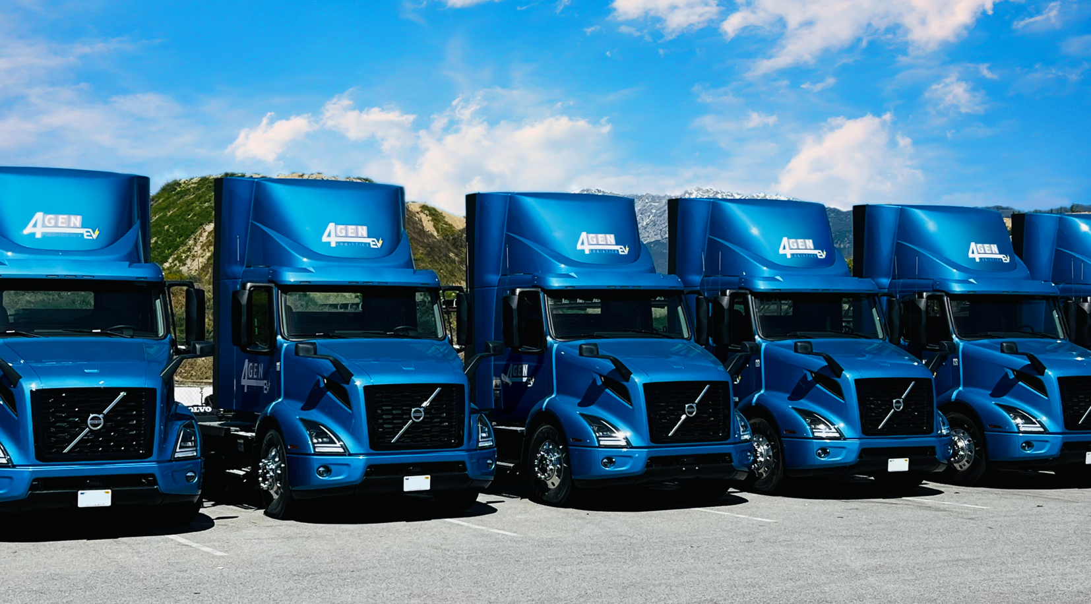
CAPTION: Volvo Trucks North America customer 4 Gen Logistics has deployed 40 additional Volvo VNR Electric trucks to haul freight between the Port of Long Beach and Southern California’s Inland Empire. 4 Gen has been gaining experience with battery-electric trucks by utilizing a Volvo VNR Electric truck that was deployed as part of the Volvo LIGHTS project in 2022.

May 6, 2024

To learn more about Volvo Trucks North America and the Volvo VNR Electric, visit the company website.

High-resolution images associated with this press release and others are available at https://press.volvotrucks.us/.

For further information, please contact:

Kyle Zimmerman
Public Relations Manager, Volvo Trucks North America
kyle.zimmerman@volvo.com
(704) 677-9757

Volvo Trucks North America, headquartered in Greensboro, North Carolina, is one of the leading heavy-duty truck manufacturers in North America. Its Uptime Services commitment is delivered by a network of nearly 400 authorized dealers across North America and the 24/7 Volvo Trucks Uptime Center. Every Volvo truck is assembled in the Volvo Trucks New River Valley manufacturing facility in Dublin, Virginia, which meets the internationally recognized ISO 9001 standard for quality, 14001 standard for environmental care and holds a dual ISO 50001/Superior Energy Performance certification at the platinum level, indicating a sustained excellence in energy management. Volvo Trucks North America provides complete transport solutions for its customers, offering a full range of diesel, alternative-fuel and all-electric vehicles, and is part of the Volvo Trucks global organization.

Volvo Trucks supplies complete transport solutions for discerning professional customers with its full range of medium- and heavy-duty trucks. Customer support is provided via a global network of dealers with 2,200 service points in about 130 countries. Volvo trucks are assembled in 12 countries across the globe. In 2023 approximately 145,000 Volvo trucks were delivered worldwide. Volvo Trucks is part of the Volvo Group, one of the world’s leading manufacturers of trucks, buses, construction equipment and marine and industrial engines. The group also provides complete solutions for financing and service. Volvo Trucks’ work is based on the core values of quality, safety and environmental care.

