P R E S S R E L E A S E

UNDER EMBARGO UNTIL APRIL 29, 2025 AT 11:25AM PT
Volvo Trucks North America Announces It Is Seeking Certification of a CARB-24 Compliant Engine for All-New Volvo VNL and VNR Models

Upon successful certification, deliveries of new trucks with CARB-24 Omnibus compliant engines are expected to begin in Q4 2025.

Volvo Trucks North America announced that it will apply for certification of a CARB-24 Omnibus compliant engine that it expects will meet the California Air Resources Board’s 2024 emissions standards and be available to order in the near future. The engine is designed to obtain a certification at the 0.05g NOx rating with reduced particulate matter (PM) emissions. This new engine continues Volvo's ambition towards zero emissions in heavy-duty transportation by 2040.

The engine will be built on the new Volvo D13 VGT (Variable Geometry Turbo) engine platform, which was launched last month at TMC. Volvo Trucks was the first North American OEM to launch a truck with a 24-volt electrical architecture. Once certified, customers will be able to order the CARB-24 Omnibus compliant engine in the all-new Volvo VNL and VNR models, with expected available configurations of 425 HP/1750 lb. ft. torque or 455 HP/1850 lb. ft. torque.

In addition to less NOx and PM, the new D13 VGT engine will enhance fuel efficiency through several innovations: a shorter seven-wave piston for improved combustion, a longer connecting rod to reduce friction, a precision needle control valve for optimized fuel flow, and a variable displacement oil pump to minimize parasitic losses. The improvement in fuel efficiency also is expected to have a direct and significant impact on CO2 reduction.

Volvo Trucks’ new engine will feature an advanced emission control system, including a fully serviceable linear exhaust aftertreatment system (EATS) and an integrated 48-volt heater used during startup and low-load situations to achieve the stringent ultra-low NOx targets. Each EATS component is designed for individual servicing or replacement, minimizing waste and maximizing operational lifespan.

This new engine complements Volvo Trucks’ earlier CARB-24 engine launch for the legacy VNL and VNR models. CARB’s Omnibus regulations aim to reduce NOx emissions by 75% and PM by 50% from heavy-duty on-road engines for engine model years 2024 through 2026—compared to current U.S. Environmental Protection Agency (EPA) standards.

"To help customers successfully navigate evolving regulations, Volvo has developed an engine that is intended to meet both EPA and CARB requirements,” said Johan Agebrand, director of product marketing, Volvo Trucks North America. “We continue to invest in powertrain and vehicle advancements that support our sustainability goals and our commitment to environmental stewardship. The Volvo VNR Electric continues to lead the Class 8 battery electric truck market in North America with over 40 percent market share and continue investments in developing other zero- and near-zero tailpipe emissions technologies.”

Fleet operators interested in learning more about the engine, which Volvo Trucks expects to be CARB-24 Omnibus compliant, or placing an order can visit their nearest Volvo Trucks dealership. Deliveries of trucks with the new engine are expected to begin in the fourth quarter of 2025.

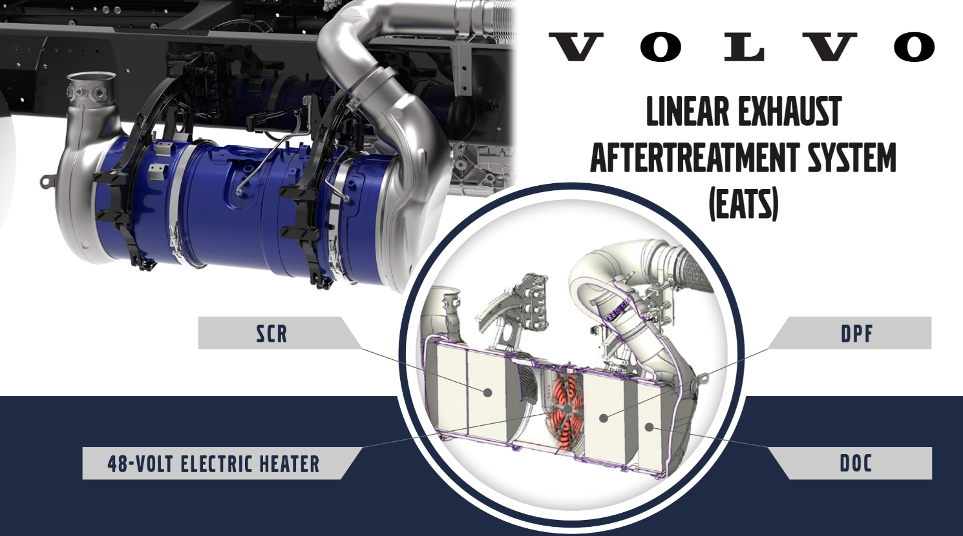

CAPTION: Volvo Trucks’ new engine features an advanced emissions control system with a fully serviceable linear exhaust aftertreatment system (EATS) and is expected to be CARB 24 Omnibus Compliant. The EATS includes the Diesel Oxidation Catalyst (DOC), Diesel Particulate Filter (DPF), and Selective Catalytic Reduction (SCR) system, all designed for efficient servicing and replacement.

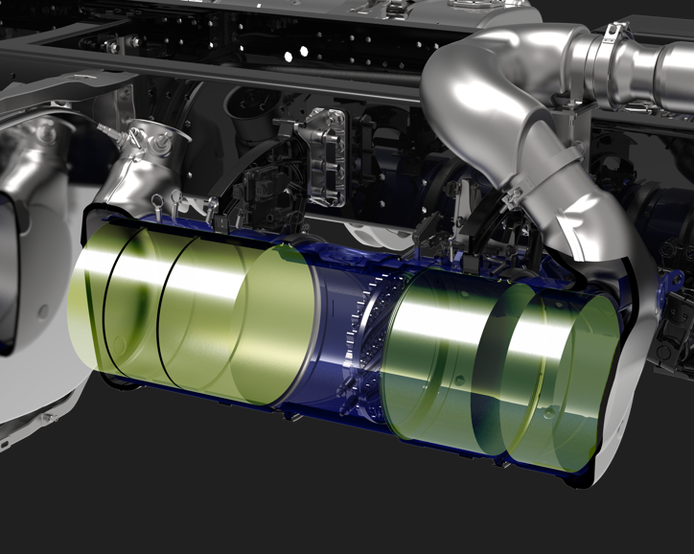
CAPTION: Volvo Trucks North America has announced it is seeking certification of a CARB-24 Omnibus compliant engine that meets low nitrogen oxide (NOx), and particulate matter (PM) emissions standards set by the California Air Resources Board.
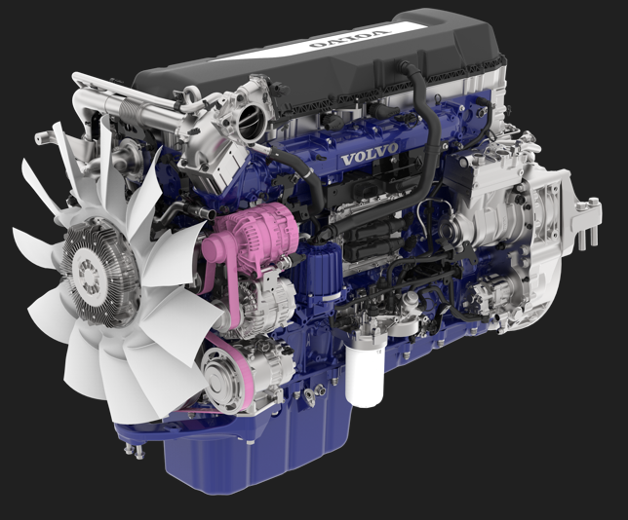
CAPTION: Volvo Trucks North America has announced it is seeking certification of a CARB-24 Omnibus compliant engine that meets low nitrogen oxide (NOx), and particulate matter (PM) emissions standards set by the California Air Resources Board.

April 29, 2025

To learn more about Volvo Trucks North America, visit the company website.

High-resolution images associated with this press release and others are available at https://press.volvotrucks.us/.

For further information, please contact:

Kyle Zimmerman
Public Relations Manager, Volvo Trucks North America
kyle.zimmerman@volvo.com
(704) 677-9757

Volvo Trucks North America, headquartered in Greensboro, North Carolina, is one of the leading heavy-duty truck manufacturers in North America. Its Uptime Services commitment is delivered by a network of nearly 400 authorized dealers across North America and the 24/7 Volvo Trucks Uptime Center. Every Volvo truck is assembled in the Volvo Trucks New River Valley manufacturing facility in Dublin, Virginia, which meets the internationally recognized ISO 9001 standard for quality, 14001 standard for environmental care and holds a dual ISO 50001/Superior Energy Performance certification at the platinum level, indicating a sustained excellence in energy management. Volvo Trucks North America provides complete transport solutions for its customers, offering a full range of diesel, alternative-fuel and all-electric vehicles, and is part of the Volvo Trucks global organization.

Volvo Trucks supplies complete transport solutions for discerning professional customers with its full range of medium- and heavy-duty trucks. Customer support is provided via a global network of dealers with 2,200 service points in about 130 countries. Volvo trucks are assembled in 12 countries across the globe. In 2023 approximately 145,000 Volvo trucks were delivered worldwide. Volvo Trucks is part of the Volvo Group, one of the world’s leading manufacturers of trucks, buses, construction equipment and marine and industrial engines. The group also provides complete solutions for financing and service. Volvo Trucks’ work is based on the core values of quality, safety and environmental care.

