P R E S S R E L E A S E

Volvo Trucks Continues Electromobility Leadership: Ten New Locations Join Certified EV Dealership Network

Volvo Trucks North America continues its leadership in developing the electromobility ecosystem to support the transition to battery-electric vehicles by adding ten new locations, three new states – Rhode Island, Utah, and Washington – and one Canadian province – Manitoba – to the roster of Volvo Trucks Certified Electric Vehicle (EV) Dealerships. Fifty-nine locations across North America have now completed the rigorous and extensive program designed to provide a comprehensive ecosystem of customer support for heavy-duty battery electric vehicle adoption.

“Before we announced the commercialization of the VNR Electric we understood that electric trucks would need to have the same level of uptime and the same quality service for our customers as our diesel trucks. That's why we created the certified EV dealer program in parallel to the commercialization plans for the VNR Electric. Today, we continue to lead the industry with 59 certified EV dealerships across the United States and Canada to serve our customers in the areas their VNR Electric trucks are deployed and decarbonizing transportation. The expansion of our certified EV dealer locations shows that battery-electric heavy-duty trucks are here to stay and will continue to scale as a viable option for freight transportation and our vision is to continue that expansion,” said Peter Voorhoeve, president, Volvo Trucks North America.

Dealership support is essential to the successful adoption of battery-electric trucks. Selling the truck is only part of the equation; it takes an entire support ecosystem to successfully transition to battery-electric trucks. Volvo’s leading network of certified EV dealerships play an important role in the introduction of new vehicle technology, serving as the main resource for the point of sale, a local resource for driver training and to perform routine maintenance and repairs to maximize customer uptime. Being prepared for routine maintenance and repairs means keeping parts in the dealer’s local inventory and having certified technicians on-site to service the Volvo VNR Electric as quickly and efficiently as possible. By partnering with dealerships that are committed to supporting the transition to sustainable transportation solutions, fleets and owner operators can make the transition to heavy-duty electric trucks smoothly with peace-of-mind knowing they are surrounded by an ecosystem of support.

In collaboration with its dealer partners, Volvo Trucks has delivered 470 Volvo VNR Electric trucks from the New River Valley Plant in Dublin, Virginia, driving the shift toward decarbonized freight transportation. These trucks have logged 4.5 million customer miles (7 million kilometers) in diverse business sectors – including grocery, last-mile delivery, drayage, warehouse distribution, U.S. mail, medical supply, utility, fleet leasing, retail, and more.

The Volvo Trucks Certified EV Dealer program was developed as part of the Volvo LIGHTS project in Southern California, where TEC Equipment supported local fleet operators in deploying the first Volvo VNR Electric demonstration trucks. In July 2021, TEC Equipment, Volvo Trucks’ largest West Coast dealer group, was designated as the nation’s first certified EV dealer. Today, Volvo Trucks has certified 59 dealer locations across 27 states — Alabama, Arizona, California, Delaware, Florida, Georgia, Idaho, Illinois, Indiana, Massachusetts, Minnesota, Missouri, Montana, New Jersey, New York, North Carolina, Ohio, Oklahoma, Oregon, Pennsylvania, Rhode Island, Tennessee, Texas, Utah, Virginia, Washington, and Wisconsin — and four Canadian provinces — British Columbia, Manitoba, Ontario, and Quebec.

The impressive reach of Volvo Trucks certified EV dealer network is largely due to its dealer partners’ commitment to providing excellent customer support and helping to guide fleet procurement decisions, as the funding and regulatory landscape continues to shift. The company congratulates these dealer locations for recently completing the certification process:

* Aber’s Truck Center - Ashland, Ohio
* Anderson Motors - Riverside, Rhode Island
* Beaver Truck Center – Winnipeg, Manitoba, Canada
* Gerry’s Truck Centre – Woodstock, Ontario, Canada (2nd location)
* M & K Truck Centers - Des Plaines, Illinois and Frankfort, Indiana (2nd and 3rd locations)
* Mountain West Truck Center, West Valley City, Utah
* TEC Equipment – Des Moines and Lacey, Washington (5th and 6th locations)
* Transport Equipment – Spokane Valley, Washington (2nd location)

Several dealership groups have completed the Volvo Trucks Certified EV Dealer designation at multiple locations, including TEC Equipment, which recently completed the process for its sixth location across three states. Vanguard Truck Centers offers the most robust network of certified EV dealerships with seven locations across six states following its acquisition of Nacarato Truck Centers in December 2023. As the company progresses toward its goal of building a robust coast-to-coast dealer support network for battery-electric trucks, Volvo Trucks is on track to certify 40 additional dealer locations across North America in 2024.

Cost is still a significant barrier to electrification, particularly at scale, so Volvo Financial Services (VFS) provides financing opportunities for dealers to support them with their shift to zero-emission solutions. Funding solutions are available to dealerships for necessary updates, such as facility improvements, parts inventory for the Volvo VNR Electric model, onsite charging station installations, dedicated EV service bays, and the acquisition of diagnostic tools and protective equipment for technicians working with high-voltage systems.

Additionally, VFS has introduced new financing options for customers that extend beyond the truck itself, covering the installation of charging infrastructure and combining service and maintenance plans into single, convenient monthly payments. This approach spreads out the initial investment costs and provides essential resources for a successful electromobility transition.

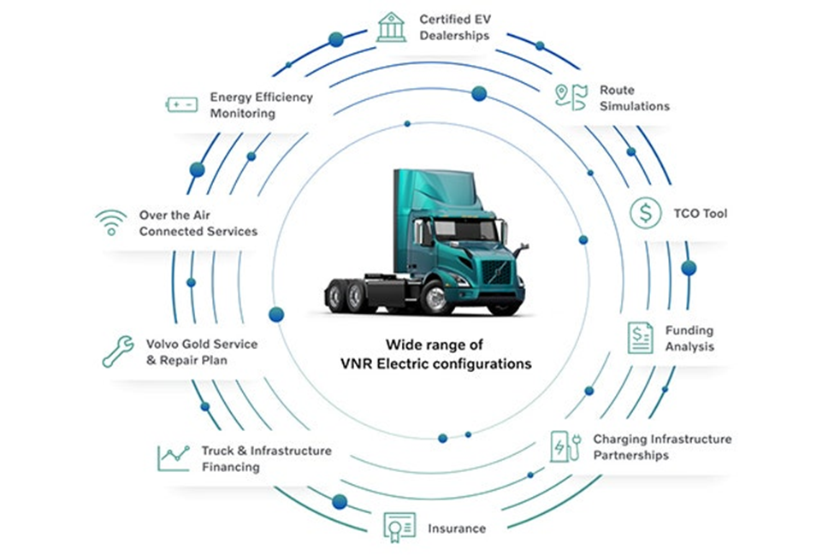

**CAPTION: Investing in the Volvo VNR Electric truck is only part of the equation—it takes an entire ecosystem supported by a Volvo Trucks Certified Electric Vehicle Dealer to successfully transition to battery-electric trucks.**

**CAPTION:** The Volvo Trucks Certified EV Dealer network has expanded to 59 locations across 27 U.S. states and four Canadian provinces across North America.

May 13, 2024

To learn more about Volvo Trucks North America and the Volvo VNR Electric, visit the company [website](https://www.volvotrucks.us/trucks/vnr-electric/).

High-resolution images associated with this press release and others are available at<https://press.volvotrucks.us/.>

For further information, please contact:

Kyle Zimmerman

Public Relations Manager, Volvo Trucks North America

[kyle.zimmerman@volvo.com](mailto:kyle.zimmerman@volvo.com)

(704) 677-9757

Volvo Trucks North America, headquartered in Greensboro, North Carolina, is one of the leading heavy-duty truck manufacturers in North America. Its Uptime Services commitment is delivered by a network of nearly 400 authorized dealers across North America and the 24/7 Volvo Trucks Uptime Center. Every Volvo truck is assembled in the Volvo Trucks New River Valley manufacturing facility in Dublin, Virginia, which meets the internationally recognized ISO 9001 standard for quality, 14001 standard for environmental care and holds a dual ISO 50001/Superior Energy Performance certification at the platinum level, indicating a sustained excellence in energy management. Volvo Trucks North America provides complete transport solutions for its customers, offering a full range of diesel, alternative-fuel and all-electric vehicles, and is part of the Volvo Trucks global organization.

Volvo Trucks supplies complete transport solutions for discerning professional customers with its full range of medium- and heavy-duty trucks. Customer support is provided via a global network of dealers with 2,200 service points in about 130 countries. Volvo trucks are assembled in 12 countries across the globe. In 2023 approximately 145,000 Volvo trucks were delivered worldwide. Volvo Trucks is part of the Volvo Group, one of the world’s leading manufacturers of trucks, buses, construction equipment and marine and industrial engines. The group also provides complete solutions for financing and service. Volvo Trucks’ work is based on the core values of quality, safety and environmental care.