P R E S S R E L E A S E
Volvo Trucks North America Unveils All-New Volvo VNL Designed to Change Everything

Volvo Trucks North America has launched a completely reimagined Volvo VNL to set new industry standards in heavy-duty trucking. The all-new Volvo VNL features the next generation of enhancements to improve total customer value, driver productivity, safety, and sustainability. The new Volvo VNL features striking aerodynamics and is engineered to achieve a fuel efficiency improvement of up to 10%. The new Volvo VNL is designed to meet the challenges and demands of the North American market and transform the driving experience. Sales will begin in the coming months with production at the Volvo Trucks New River Valley Plant in Dublin, Virginia.

“The all-new Volvo VNL was designed to change everything. However, change doesn’t only come with a redesigned truck—this product introduction is the start of a new era for Volvo Trucks, our customers, and their drivers—a quantum leap forward,” said Peter Voorhoeve, president, Volvo Trucks North America. “We started this project with a blank sheet of paper and thoroughly analyzed the trends and transformations that will impact the industry and our customers’ needs, including the sustainability and transportation demands of the future. When we launched the first generation of the Volvo VN in 1996, its ‘unconventional’ aerodynamic body style set a new standard for the North American trucking industry. We did the unthinkable in 2007 when we introduced the I-Shift in North America and spurred the industry’s transition toward automated manual transmissions. As we bring the all-new Volvo VNL to market, we are excited to once again introduce innovations that will shape the future of the transportation industry for years to come.”

The new Volvo VNL will be the platform for all upcoming technologies, including future transportation solutions of battery-electric, fuel cell and internal combustion engines running on renewable fuels including hydrogen. The first 24-volt electrical infrastructure in the North American trucking industry and active safety features that are introduced in this new generation of Volvo trucks will be the standard for the future commercialization of fully autonomous trucks. The new Volvo VNL is integral to Volvo Trucks’ vision towards zero emissions and zero accidents.

With a focus on how Volvo Trucks can generate the most value for customers, their drivers, and society at large, the new Volvo VNL takes the commercial freight transport industry to the next level by working relentlessly on improvements in five key areas—Fuel Efficiency, Safety, Driver Productivity, Connected Services, and Uptime.

Transforming Truck Fuel Efficiency with Redefined Aerodynamics & Driveline Enhancements
Aerodynamic resistance has a major impact on the fuel efficiency of a truck. The streamlined and more angular, wedge-shaped cab design of the new Volvo VNL, featuring a dramatically redesigned windshield, is a key factor in achieving up to 10% improvement in fuel efficiency. Additional aerodynamic gains were created from the integration of the curved and bonded windshield, tighter clearances around turbulent air areas like wheel openings, the bumper and the hood, chassis fairings and promoting a tighter trailer gap. These designs, all key components of the aerodynamic gains, were developed and tested in parallel with Volvo Trucks’ SuperTruck 2.

Volvo Trucks engineers also made significant improvements to the already class-leading powertrain offering. The new Volvo VNL is powered by the latest generation D13 engine that delivers improved fuel efficiency, performance, and durability. The D13 engine is available in four horsepower ratings, ranging from 405 to 500hp and three torque ratings from 1750 to 1950 lb-ft of torque. These different power options are designed to suit different applications and incorporate the improved and optimized I-Shift transmission, which features up to 30% faster shift speeds. When combined with the I-Torque powertrain solution, the D13 can deliver even greater fuel savings, best-in-class versatility, and drivability.

Comprehensive Approach to Elevating Safety Features
Safety is in Volvo Trucks’ DNA, and the engineers focused on new and improved proprietary active and passive safety features to continue the company's journey towards zero accidents. A variety of class-leading active safety systems are offered with the new Volvo VNL, including Volvo Active Driver Assist Plus with Pilot Assist which provides active lane centering. Volvo Active Driver Assist Plus is powered by Volvo Dynamic Steering which improves maneuvering at all speeds, including more controlled backing, increases stability at all road speeds, and adapts and corrects for crosswinds, highway crowning, soft shoulders, or emergency situations like tire failure. The new pedestrian detection feature alerts the driver when a pedestrian or bicyclist may be in their path or blind spots and will activate frontal automatic emergency braking for objects directly in the path of travel.

Class-leading passive safety systems offered in the new Volvo VNL include the bonded and wrapped windshield providing panoramic views. This not only improves aerodynamics for the Volvo VNL, but it also improves visibility for drivers, bolstering safety and reducing wind noise in the cab. The cab of the new Volvo VNL is designed according to Volvo Trucks’ leading crash test standards and will offer a side-curtain airbag, with options for a driver-only or driver and passenger airbags, a North American industry first. Cabs are constructed of high-strength steel to deflect the energy of a crash to reduce the chance of injury. Additionally, Volvo Trucks’ flared frame rails allow the powertrain to drop down below the cab to protect the driver. E-Call, an innovative new safety feature, connects the driver to emergency services where cellular connectivity is available and provides precise location details. This occurs automatically in the event of a rollover crash or airbag deployment.

Redefining Comfort and Efficiency with a Driver-Centric Design
The new Volvo VNL is designed with the driver in mind to optimize comfort, efficiency and safety when working, living, and resting. A new, optional air suspension system, GRAS (Global Rear Air Suspension), uses dual leveling rods to reduce roll and pitch angles, improve lateral stability, and minimize road shocks, maintaining a constant ride height. The GRAS system offers superior ride quality, stability, and handling for the new Volvo VNL. The GRAS and the supporting Volvo Smart Suspension software work seamlessly with the Volvo Dynamic Steering system to provide precise steering control and reduce driver fatigue regardless of load, terrain, road condition and varying engine torque levels. GRAS with Volvo Smart Suspension is designed to make deliveries easier as drivers are provided with three different settings to adjust the suspension for different loading and unloading conditions.

The new Volvo VNL features Volvo Trucks’ most efficient idle management tool to help reduce or eliminate engine idling when the vehicle is stopped or parked. The new ultra-quiet, proprietary, integrated Volvo Parking Cooler is a climate-control option that utilizes the onboard 24-volt battery system to power the cab’s HVAC when parked, reducing emissions, engine wear and lowering fuel costs. The Volvo Parking Cooler enhances the resting experience by eliminating noise and vibration from idling. For drivers parked in areas where idling is prohibited, the integrated Volvo Parking Cooler maintains a comfortable climate to maximize driver health, safety and well-being.

Volvo Trucks evaluated every detail of the driver experience, from selecting materials that provide a premium look and feel, to redefining cab lighting and optimizing storage to create a “home away from home” experience for drivers. The new Volvo VNL features newly introduced or dramatically improved amenities, including an optional folding bunk allowing easy access to the dinette space, a singular multi-functional control panel in the back of the cab, upgraded insulation for climate control and noise reduction, a larger refrigerator, and enough power options to support any device.

Seamless Connectivity with Integrated Digital Solutions
The integrated Volvo Connect, an all-in-one fleet management portal, houses all of Volvo Trucks’ digital services under one platform including vehicle data insights, diagnostics, remote programming, fuel economy reports, safety reports, and location services. A complimentary, 24-month Volvo Connect subscription comes standard with all new Volvo trucks.

With the new Volvo MyTruck app, drivers can stay in touch with their truck by seeing their estimated remaining fuel range, DEF levels, and coolant levels as well as receiving notifications about potential issues such as light malfunctions, low washer fluid levels and other important items so they can address them at rest breaks or in their pre-trip inspection. Additionally, with the MyTruck app, drivers can schedule specific days and times to start the climate control to have the cabin climate reach their preferred temperature before arriving to their truck to start their workday.

Proactive Approach to Maximizing Uptime and Efficiency
The Blue Service Contract, an optional, comprehensive dealer managed service plan, leverages Volvo’s connected services to boost uptime and efficiency. By utilizing Volvo’s connected services, dealers have real-time data when maintenance is due and diagnostic information for any detected fault codes. This enables the customer to schedule service in advance and have dealers perform remote programming updates to maintain the health of the truck and prevent unplanned downtime. During dealer afterhours, Volvo Trucks’ Uptime Center continues to remotely monitor the truck and will alert plan subscribers if any critical issues arise.

Volvo Trucks North America’s new 24-volt electrical architecture, the first in North America, helps to minimize battery and electrical failures and improve serviceability when it comes to pinpointing and repairing electrical issues. A new linear exhaust aftertreatment system will be easier to service and deliver better DEF treatment for an even cleaner system.

Industry-First Option Packaging is Introduced in North America
Volvo Trucks has transformed the spec’ing process for the new Volvo VNL series by introducing packaging options for powertrain and safety, an industry first that simplifies and optimizes the configuration and ordering process and streamlines the assembly operations. Customers can choose the optimal powertrain package for their application duty-cycle and fuel efficiency goals by selecting from three powertrain packages that feature the Volvo D13 engine with five different horsepower and torque ratings available. Additionally, customers can select from several safety packages to ensure that their truck is equipped with the appropriate technology to meet their fleet safety goals of protecting their drivers, those around their trucks, and the assets they are hauling. Bundling the proper safety features promotes Volvo’s goal of zero accidents.

The all-new Volvo VNL is conveniently packaged into four exterior and interior trim levels – Core, Edge, Edge Black and Ultimate – with six cab configurations, each designed to fit customers’ preference, brand identity and operational use.

New Volvo VNL Available with Six Cab Configurations:
- VNL 300 Day Cab
- VNL 440 42-inch Mid-Roof Sleeper
- VNL 640 62-inch Mid-Roof Sleeper
- VNL 660 62-inch Full-Height Sleeper
- VNL 840 74-inch Mid-Roof Sleeper
- VNL 860 74-inch Full-Height Sleeper

New Configurator Tool Helps Customers Explore and Design the Ideal Truck
To explore the new Volvo VNL features and trim levels in an interactive way, Volvo Trucks has developed a new state-of-the-art online Volvo VNL configurator. The configurator provides detailed information on the features and benefits of each trim level and cab option, as well as a 360-degree view of the truck interior and exterior.

Dealers Prepared to Guide Customers on Transition to New Volvo VNL
Training will be available to dealer sales staff to enable them to consult with customers on the ideal Volvo VNL configuration for their respective transport applications. Dealers’ service representatives have access to extensive competency development, with e-learning and in-person instructor-led courses from Volvo Academy, to be fully trained to support the new Volvo VNL when trucks start to arrive at dealerships.

“Progressive solutions are needed to help tackle the challenges of the transportation industry, including the need for increased productivity and efficiency while also reducing emissions. Companies must prioritize driver retention and well-being with driver-friendly features and advanced technologies, providing an exceptional driving experience that is key for fleets to attract and retain drivers,” said Voorhoeve. “With an interior and exterior design that stops you in your tracks, every innovation introduced in the all-new Volvo VNL was made with the goal to make a driver’s job a little easier and safer and provide a new level of customer value. As we completely reimagined the Volvo VNL, we looked at the future of transportation and saw an opportunity to set new industry standards and sustainably shape the world we want to move.”
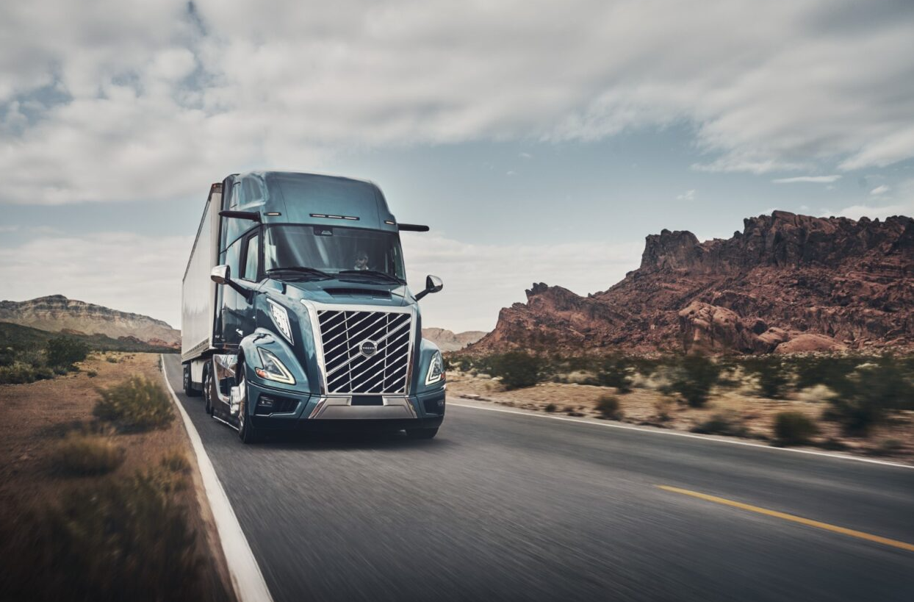

CAPTION: Volvo Trucks North America completely redesigned the new Volvo VNL, filling the all-new model with hundreds of next-generation features that will empower fleets to improve safety, productivity, profitability, and sustainability like never before.

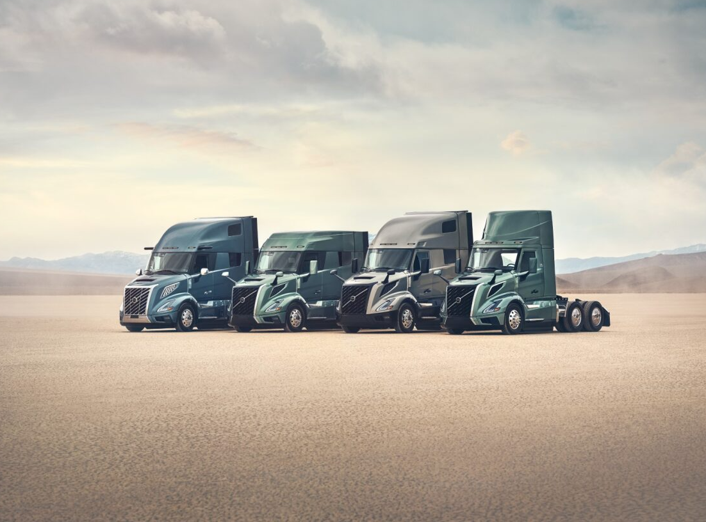

CAPTION: The all-new Volvo VNL is conveniently packaged into four exterior and interior trim levels with six cab configurations, each designed to fit customers’ preference, brand identity and operational use.

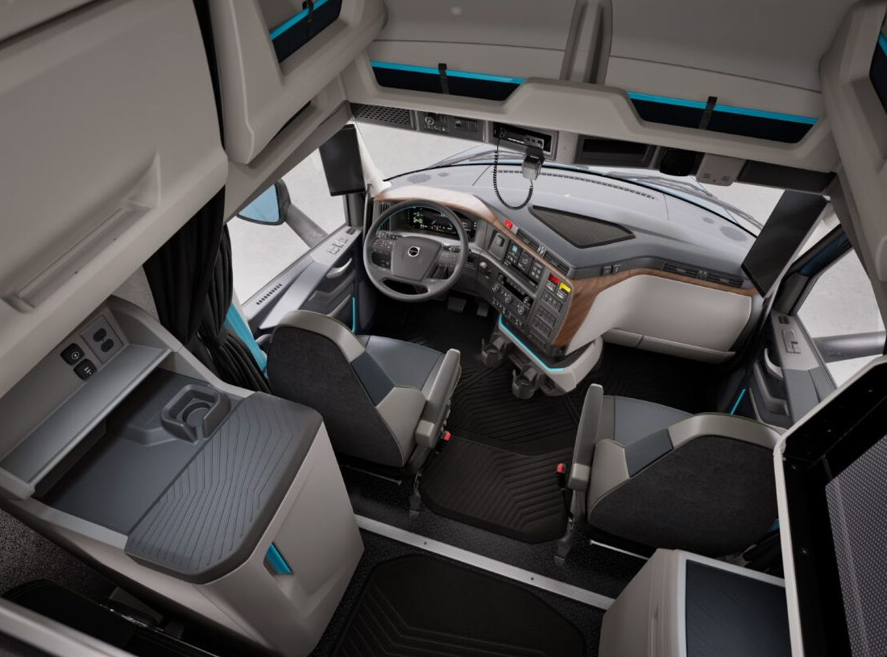

CAPTION: The new Volvo VNL is designed with the driver in mind to optimize comfort, efficiency and safety when working, living, and resting. Volvo Trucks evaluated every detail of the driver experience, from selecting materials that provide a premium look and feel, to redefining cab lighting and optimizing storage to create a “home away from home” experience for drivers.

January 23, 2024

To learn more about Volvo Trucks North America and the all-new Volvo VNL, visit the company website.

For further information, please contact:

Kyle Zimmerman
Public Relations Manager, Volvo Trucks North America
kyle.zimmerman@volvo.com
(704) 677-9757

Volvo Trucks North America, headquartered in Greensboro, North Carolina, is one of the leading heavy-duty truck manufacturers in North America. Its Uptime Services commitment is delivered by a network of nearly 400 authorized dealers across North America and the 24/7 Volvo Trucks Uptime Center. Every Volvo truck is assembled in the Volvo Trucks New River Valley manufacturing facility in Dublin, Virginia, which meets the internationally recognized ISO 9001 standard for quality, 14001 standard for environmental care and holds a dual ISO 50001/Superior Energy Performance certification at the platinum level, indicating a sustained excellence in energy management. Volvo Trucks North America provides complete transport solutions for its customers, offering a full range of diesel, alternative-fuel and all-electric vehicles, and is part of the Volvo Trucks global organization.

Volvo Trucks supplies complete transport solutions for discerning professional customers with its full range of medium- and heavy-duty trucks. Customer support is provided via a global network of dealers with 2,300 service points in about 130 countries. Volvo trucks are assembled in 12 countries across the globe. In 2022 approximately 145,000 Volvo trucks were delivered worldwide. Volvo Trucks is part of the Volvo Group, one of the world’s leading manufacturers of trucks, buses, construction equipment and marine and industrial engines. The group also provides complete solutions for financing and service. Volvo Trucks’ work is based on the core values of quality, safety and environmental care.

