P R E S S R E L E A S E
Safety Drives Everything in the All-New Volvo VNL

Volvo Trucks North America recently introduced the completely reimagined, all-new Volvo VNL, designed to revolutionize the heavy-duty trucking industry and set new standards for safety. With the vision of achieving zero accidents, Volvo Trucks’ unwavering commitment to safety is demonstrated through the all-new Volvo VNL’s next-generation driver assistance and occupant protection technologies.

“At Volvo Trucks, developing safety innovations that help protect drivers and those around the trucks is a process that never ends. You don’t become the brand known for safety by playing it safe,” said Peter Voorhoeve, president, Volvo Trucks North America. “Safety is in our DNA and at the heart of every truck we build. The all-new Volvo VNL sets the new standard for active and passive safety in North America. At Volvo Trucks we have a vision for zero accidents, because it’s the only number that’s acceptable.”

Advanced Driver Assistance Safety Systems

The all-new Volvo VNL features a suite of class-leading driver assistance systems, including the Volvo Active Driver Assist (VADA) package that comes standard across all VNL models. This package features forward collision avoidance technology to assist drivers in maintaining safe speeds and distances, offering adaptive cruise control, and providing audible and haptic alerts to help the driver maintain a safe following distance to the vehicle ahead.

Additionally, the new optional Volvo Active Driver Assist Plus (VADA Plus) provides support for lane changes and active lane centering, as well as a variety of alerts to help drivers reduce the risk of side-collisions. It is powered by Volvo Dynamic Steering (VDS) to help drivers maintain effective maneuvering, steering control, and stability under various speeds and road conditions – including high crosswinds, highway crowning, and emergency situations like tire failure – thereby reducing driver fatigue and bolstering safety. The oversteer guidance in VDS, which is included in the VADA Plus option, provides additional support to the driver to avoid rollover events. When combined with I-Shift, Volvo’s automated manual transmission, VDS makes steering at low-speeds easier than ever.

Volvo's Pedestrian Detection Feature

The new forward pedestrian detection feature, part of the standard VADA package, alerts the driver to pedestrians or bicyclists in their path, and can activate frontal automatic emergency braking when objects are directly in the path of travel. The camera system can also provide long-range pedestrian detection. With the VADA Plus option, short-range detection senses pedestrians and bicyclists that may appear in blind spots immediately on either side of the truck and trailer. This innovative technology underscores Volvo’s commitment to continually improving safety features and ensuring peace of mind for drivers, helping to reduce accidents.

Maximizing Driver Visibility

New camera solutions are designed to give drivers additional tools to improve their visibility, including a forward-looking camera that recognizes road signs and displays them on the digital 12-inch Digital Information Display (DID) to give the driver more time to make adjustments safely. Overspeed warnings, based on the last posted speed limit sign, can be enabled. Navigation can also be viewed on the DID or by using the optional 9-inch infotainment center, where drivers can also scroll through up to seven exterior camera views.

The fully integrated Camera Monitoring System (CMS) complements traditional side mirrors with a wider range of visibility which can help drivers reduce risk of collision during lane changes or backing maneuvers. With the CMS, smaller cab mounted side mirrors can be used, further improving the aerodynamics of the truck. Intelligent high beams turn on and off automatically based on the surrounding light environment to deliver optimal driver visibility. Cornering lamps anticipate needed sightlines, providing additional lighting for entering or exiting curves and turns at low speeds.

The all-new Volvo VNL’s wrapped windshield provides drivers expansive, panoramic views. This design choice enhances both aerodynamics and visibility, significantly boosting safety while also diminishing wind noise within the cab. Crafted with a distinct slope and curvature, the windshield ensures an unobstructed view of the road ahead, thereby allowing drivers more time to respond to potential hazards, effectively lowering the risk of collisions. Additionally, the driver’s seat position can be adjusted to optimize these exceptional site lines further. In terms of resilience, the windshield is engineered to minimize shattering upon impact and is securely bonded to the vehicle’s frame. The windshield comes standard with laminated safety glass to reduce the risk of injury from flying debris during a collision. For added protection, laminated safety glass is available as an option for both doors and rear windows, ensuring comprehensive safety from every angle.

Class-Leading Driver Safety Features

Regardless of how sophisticated the technology and how careful the driver is, there may be situations where an accident is unavoidable. The all-new Volvo VNL addresses this reality with intelligent driver protection features designed to help mitigate the risk of serious injuries and safeguard lives in the event of an accident.
Volvo’s pioneering invention of the three-point safety belt in 1959, now available in various colors to encourage usage and driver compliance, underscores its long-standing commitment to safety. Volvo Trucks is the only Class 8 manufacturer with a driver frontal airbag as a standard feature, offering an added layer of protection to the driver’s face and upper body. Marking another industry-first in North America, the all-new Volvo VNL introduces side-curtain airbags. These innovative airbags extend along the doors and windows, providing superior protection during a rollover, with customization options available for both driver and passenger coverage.
Designed to meet the strenuous Swedish Impact Test standards, the cab of the all-new Volvo VNL is constructed using high-strength steel, which is up to three times stronger than aluminum, is engineered to absorb and deflect the energy of a crash to reduce the chance of injury. The vehicle comes equipped with advanced driver frontal airbags as a standard feature, while offering the option of side curtain airbags for enhanced protection. Its impact-absorbing dash and steering column are specifically designed to protect drivers’ limbs and joints during a collision. Volvo Trucks’ unique flared frame rails, incorporated into the all-new Volvo VNL, are another example of Volvo’s legacy of prioritizing driver safety through innovated engineering solutions. The flared frame rails are designed to lower the engine and transmission beneath the cab in frontal impacts, moving these components away from the driver. The cab also features reinforced hinges that ensure doors remain securely shut during collisions and include an automatic unlock feature to facilitate the driver’s exit post-crash.

Smart Safety Technologies for Emergency Situations

In the event of an airbag deployment or rollover, the all-new Volvo VNL activates a suite of intelligent safety protocols to further protect the vehicle and its occupants. These include automatic engine shutdown that cuts the fuel supply to significantly diminish the risk of fire outbreak, and the activation of hazard lights to alert nearby drivers. The emergency parking brake is engaged by a frontal airbag deployment to stabilize the vehicle, providing further protection for the driver.

Volvo Trucks’ innovative new safety feature, the E-Call system, connects the driver directly to emergency services following an airbag deployment or rollover event, where cellular connectivity permits. This feature is designed to automatically dial 911 in the wake of a rollover or when air bags are deployed, promptly dispatching emergency responders to the vehicle’s precise location. An additional service can be added to allow drivers to provide a call back number for E-Call or the optional SOS button.

Volvo Trucks’ Vision: Zero Emissions, Zero Accidents

The all-new Volvo VNL aligns with Volvo Trucks’ commitment to zero emissions and zero accidents. By focusing on fuel efficiency, safety, driver productivity, connected services, and uptime, Volvo aims to lead the transformation in commercial freight transport towards a safer and more sustainable future.



CAPTION: Volvo's forward pedestrian detection feature, part of the Volvo Active Driver Assist package that is standard on every all-new Volvo VNL truck, uses cameras to sense pedestrians and bicyclists in their path, activating frontal automatic emergency braking when objects are directly in the path of travel.

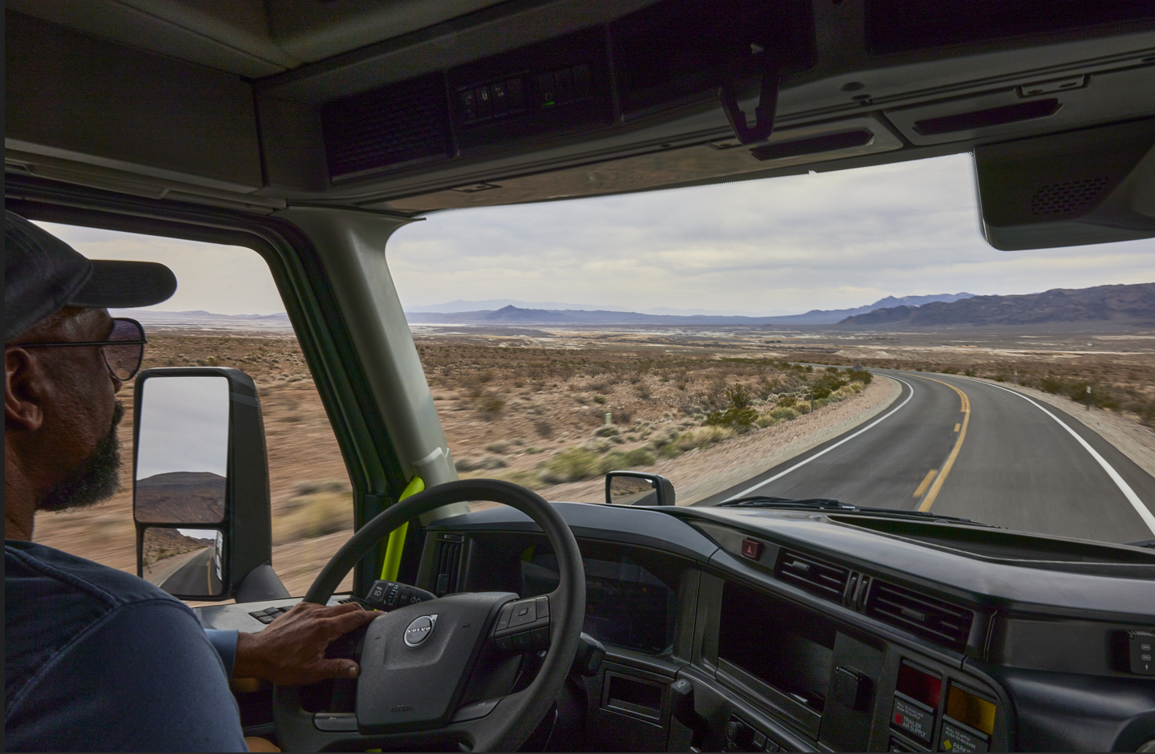

CAPTION: Drivers have unparalleled visibility and safety in the all-new Volvo VNL with its bonded and wrapped panoramic windshield. Engineered for optimal aerodynamics and visibility, it reduces wind noise and enhances reaction time for drivers, with laminated safety glass to minimize flying debris in case of a collision.

March 28, 2024

To learn more about Volvo Trucks North America, visit the company website.

High-resolution images associated with this press release and others are available at https://media.volvotrucks.us/.

For further information, please contact:

Kyle Zimmerman
Public Relations Manager, Volvo Trucks North America
kyle.zimmerman@volvo.com
(704) 677-9757

Volvo Trucks North America, headquartered in Greensboro, North Carolina, is one of the leading heavy-duty truck manufacturers in North America. Its Uptime Services commitment is delivered by a network of nearly 400 authorized dealers across North America and the 24/7 Volvo Trucks Uptime Center. Every Volvo truck is assembled in the Volvo Trucks New River Valley manufacturing facility in Dublin, Virginia, which meets the internationally recognized ISO 9001 standard for quality, 14001 standard for environmental care and holds a dual ISO 50001/Superior Energy Performance certification at the platinum level, indicating a sustained excellence in energy management. Volvo Trucks North America provides complete transport solutions for its customers, offering a full range of diesel, alternative-fuel and all-electric vehicles, and is part of the Volvo Trucks global organization.

Volvo Trucks supplies complete transport solutions for discerning professional customers with its full range of medium- and heavy-duty trucks. Customer support is provided via a global network of dealers with 2,200 service points in about 130 countries. Volvo trucks are assembled in 12 countries across the globe. In 2023 approximately 145,000 Volvo trucks were delivered worldwide. Volvo Trucks is part of the Volvo Group, one of the world’s leading manufacturers of trucks, buses, construction equipment and marine and industrial engines. The group also provides complete solutions for financing and service. Volvo Trucks’ work is based on the core values of quality, safety and environmental care.

