P R E S S R E L E A S E
Volvo Trucks North America Launches the New Volvo D13 Variable Geometry Turbo Engine

To power the major launch of the all-new Volvo VNR, Volvo Trucks North America has launched the new Volvo D13 VGT (Variable Geometry Turbo) engine. The new Volvo D13 VGT engine will be standard in the all-new Volvo VNR and customers will also be able to select in the all-new Volvo VNL day cab. The new D13 VGT engine builds on the game changing improvements launched with the all-new D13 Turbo Compound engine, which is standard on the all-new Volvo VNL.

Focusing on fuel efficiency and durability, Volvo Trucks has made key enhancements to the D13 VGT engine including:

- Advanced Piston Design: The improved seven-wave piston optimizes air and fuel mixture control, resulting in more efficient combustion. The piston height has been decreased and paired with a longer connecting rod to minimize cylinder sidewall pressure, reducing friction and enhancing overall performance. In addition to improving the combustion process, the seven-wave design allows for a greater dispersion of heat across the top of the piston head, lowering the overall temperature and reducing NOx output.

- Enhanced Fuel Injector: Smaller needle control valves in the fuel injectors provide precise and rapid control over the fuel flow rate, leading to improved fuel atomization, better combustion efficiency, and enhanced engine performance.

- Variable Displacement Oil Pump: This innovative pump dynamically adapts to the engine's oil pressure demands, minimizing parasitic losses, reducing wear and tear, and improving efficiency.

The new Volvo D13 VGT engine also utilizes the 24-volt electrical system, first introduced by Volvo in North America with the all-new Volvo VNL. The 24-volt electrical architecture paves the way to use lighter components and can prolong the life of those components due to the lower amperage of the system.

"As we continue to innovate and improve our powertrain offerings, the launch of the Volvo D13 VGT engine marks another significant step forward in our commitment to fuel efficiency and sustainability," said Peter Voorhoeve, president of Volvo Trucks North America. "Fuel costs remain the second highest expense for fleets in North America and our powertrain improvements represent an up to 3 percent fuel efficiency improvement over our previous generation engine. The D13 VGT engine is built to deliver the performance and reliability our customers expect, while also contributing to a cleaner, more efficient future."

The Volvo D13 VGT engine is now available for order in the all-new Volvo VNR and the all-new Volvo VNL models. Customers can choose from engine options offering 405, 425, 435, and 455 HP, with torque ratings ranging from 1450 to 1850 lb. ft. Customers purchasing the all-new Volvo VNR when orders begin will also have the option to select the D13 Turbo Compound engine which is well suited for fleets using the VNR in a highway application.

Fleet operators can learn more and place orders by visiting their nearest Volvo Trucks dealership, where the sales staff have been fully trained on the engine’s capabilities.

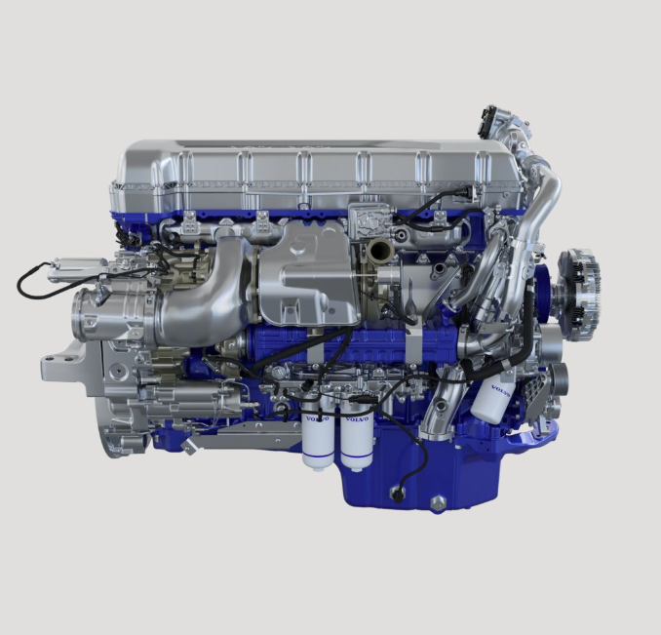
CAPTION: Volvo Trucks North America has introduced the new Volvo D13 VGT (Variable Geometry Turbo) engine, now available in the all-new Volvo VNR and all-new Volvo VNL day cab.

March 10, 2025

For more information on the new Volvo D13 VGT engine visit volvotrucks.us.

High-resolution images associated with this press release and others are available at https://press.volvotrucks.us/.

For further information, please contact:

Kyle Zimmerman
Public Relations Manager, Volvo Trucks North America
kyle.zimmerman@volvo.com
(704) 677-9757

Volvo Trucks North America, headquartered in Greensboro, North Carolina, is one of the leading heavy-duty truck manufacturers in North America. Its Uptime Services commitment is delivered by a network of nearly 400 authorized dealers across North America and the 24/7 Volvo Trucks Uptime Center. Every Volvo truck is assembled in the Volvo Trucks New River Valley manufacturing facility in Dublin, Virginia, which meets the internationally recognized ISO 9001 standard for quality, 14001 standard for environmental care and holds a dual ISO 50001/Superior Energy Performance certification at the platinum level, indicating a sustained excellence in energy management. Volvo Trucks North America provides complete transport solutions for its customers, offering a full range of diesel, alternative-fuel and all-electric vehicles, and is part of the Volvo Trucks global organization.

Volvo Trucks supplies complete transport solutions for discerning professional customers with its full range of medium- and heavy-duty trucks. Customer support is provided via a global network of dealers with 2,200 service points in about 130 countries. Volvo trucks are assembled in 12 countries across the globe. In 2024 approximately 134,000 Volvo trucks were delivered worldwide. Volvo Trucks is part of the Volvo Group, one of the world’s leading manufacturers of trucks, buses, construction equipment and marine and industrial engines. The group also provides complete solutions for financing and service. Volvo Trucks’ work is based on the core values of quality, safety and environmental care.

