P R E S S R E L E A S E

Volvo Trucks Launches the All-New Volvo VNR to Redefine Regional Haul with Enhanced Safety and Fuel Efficiency

As demand for safer and more efficient fleets grows, Volvo Trucks North America continues to answer the industry's call with the launch of the all-new Volvo VNR—delivering the safest, most versatile, and fuel-efficient solution purposefully designed to reshape the regional haul market. Featuring a 90 percent redesign over the previous generation truck, the all-new Volvo VNR integrates the latest proprietary safety systems from the ground up. The all-new Volvo VNR is optimized for shorter-range operations, with a tighter turning radius ideal for navigating urban routes, while having the versatility to carry out long-haul operations when called upon. Advanced safety, connectivity, maneuverability, and visibility features further enhance its capability, making it well suited for areas with heavy pedestrian activity. Production will take place at the Volvo Trucks New River Valley Plant in Dublin, Virginia, with sales starting in the coming months.

“Volvo Trucks has a legacy of providing innovative, purpose-built solutions. The all-new VNR is a versatile option that was designed specifically for the demanding nature of regional and urban delivery. Fleets now have the tools to tackle a wide range of operational needs with our most customizable truck,” said Peter Voorhoeve, president, Volvo Trucks North America. “Once again, Volvo Trucks is introducing a truck that was designed to change everything. Together, the street-smart VNR and our flagship VNL can address a wide range of fleet operational needs.”

**Versatility and Customization**

The new Volvo VNR state-of-the-art configurator helps fleets customize the ideal truck for their operations, including selecting the cab model, trim level, and designated technology and driver amenity package. The all-new Volvo VNR was developed with versatility in mind and is available in a variety of Class 8 configurations, including 4x2, 6x2, and 6x4 tractors, as well as straight trucks with multiple body types, to put the customer in the right truck for their application.

* VNR 300 – the number one choice for customers who need a regional haul tractor, perfectly suited for the demands of urban delivery. With an amazingly tight wall-to-wall turning radius, the all-new Volvo VNR 300 is one of the most maneuverable Class 8 trucks on the road.
* VNR 440 – a compact, highly maneuverable mid-roof 42” sleeper that provides a comfortable place to rest when a driver has reached a mandatory break or must stay an extra night on the road.
* VNR 640 – a mid-roof 62” sleeper ideal for drivers operating for multiple days in bulk haul or flatbed deliveries that can be weight sensitive.
* VNR 660 – the premium and most spacious all-new Volvo VNR 62” high-roof sleeper in the new lineup. This truck is well suited for both regional deliveries and long-haul trips, combining aerodynamics for highway driving with the tight turning radius and maneuverability of the other VNR cab configurations. The all-new Volvo VNR 660 is also the ideal choice for fleets needing a sleeper truck while operating in areas with stringent length restrictions.
* VNR straight truck – the ultimate adaptable solution and available in any cab size – day cab or sleeper options in the 300, 440, 640, and 660 models. The customizable configurations are designed to meet the demands of diverse applications whether outfitted as a box van, flatbed, roll back, expeditor or tanker application and provide unmatched versatility and performance.

The robust design of the all-new Volvo VNR series features high-strength steel construction and offers versatile solutions with customizable exterior and interior design options, available in two trim levels — Core and Edge.

The stylish yet practical Core trim level is ideal for fleets with multiple drivers or applications that require frequent cab entry and exit. The interior door panels, kick panels, and dash are all made of tough molded polymers, making it easy to clean and to hide wear and tear. Exterior trim pieces that may be impacted by high-traffic operations can be repaired and replaced with no painting needed.

The Edge trim level features bold styling with chrome accents around the grill and air intake, as well as a new chrome-plated metal bumper designed to handle regional and local deliveries. Other upgrades that offer an elevated driver experience include a leather-wrapped steering wheel, soft touch dash and armrests.

**24-Volt Electrical Architecture**

As part of its 90 percent redesign, the all-new Volvo VNR incorporates the 24-volt electrical architecture that was introduced with the all-new Volvo VNL. Volvo Trucks was the first OEM in North America to introduce a 24-volt electrical architecture as the need for more voltage allowing for less amperage is becoming critical in North America. Volvo felt it important to bring their proven, global 24-volt system to the all-new Volvo VNR as this advanced system is setting a new benchmark for the trucking industry, supporting everything from the powertrain to active safety systems, uptime, and driver productivity. The 24-volt architecture allows for faster and more accurate diagnostics, minimizing battery and electrical failures. Its design incorporates lighter components and more reliable, serviceable wiring harnesses, reducing wear and tear due to the lower amperage while ensuring maximum operational efficiency. The move to a 24-volt architecture also paves the way for future innovations and reinforces Volvo Trucks’ commitment to leading the industry into the next generation of mobility.

**Safety Innovations**

The all-new Volvo VNR features the proprietary Volvo Active Safety Platform, which includes Volvo Active Driver Assist (VADA) with forward collision warning, lane departure warning, adaptive cruise control, and automatic emergency braking. Industry-first safety features such as the E-Call emergency response system and integrated cab-mounted side curtain airbags available on both the driver and passenger side are all part of the latest step in Volvo’s commitment to developing next-generation safety and accident-prevention technologies.

Optional advanced safety packages (VADA Plus) with Volvo Dynamic Steering (VDS) offer lane keep support and blind spot monitoring. Using radar on each side of the truck, the system detects when other road users, like pedestrians or cyclists, might be in the truck’s path. The passenger-side system informs the driver via a solid light in the A-pillar or Camera Monitor System and flashes with audible warnings if the turn signal is activated or the vehicle is turning. A driver-side option is also available.

VDS helps drivers maintain effective maneuvering, steering control, and stability under various speeds and road conditions – including high crosswinds, highway crowning, and emergency situations like tire failure – reducing driver fatigue and neck and shoulder strain while bolstering safety.

The fully integrated Camera Monitor System allows for smaller, more aerodynamic cab-mounted mirrors versus the large, traditional mirrors. The Camera Monitor System provides superior visibility and supports safe maneuvering for the driver.

Driver productivity is further supported with infra-red technology for low-light operation that eliminates blinding from headlights of the vehicles behind the truck. Digital reference lines help the driver judge the end of the trailer and the distance to objects behind the truck, while the Auto Pan feature allows the camera to follow the trailer. These advanced safety features support the driver’s ability to make lane changes more safely in congested areas.

The tire monitoring system provides general pressure and temperature warnings for the truck tires as well as low-battery warnings for valve sensors. Choosing the optional Advanced Tire Pressure Monitoring System provides automatic updates on tire location whenever tires are rotated.

The electronic parking brake offers both auto-activate and auto-release functions. When the truck detects no driver activity and the door opens, a safety alarm sounds. Then the auto-activate function engages the parking brake. This feature is especially beneficial for drivers who frequently enter and exit the cab during deliveries, helping to ensure that the brake is engaged automatically for added safety.

**Fuel Efficiency Improvements**

The all-new Volvo VNR series delivers up to 7.5% improved fuel efficiency compared to the legacy VNR through enhanced aerodynamics, powertrain innovations, and idle reduction technologies reducing fuel costs and emissions for fleets. Eco-roll technology will disengage the driveline on a downhill grade and let the truck roll for an optimal amount of time to help save energy.

The wedge-shaped cab of the all-new Volvo VNR guides airflow to balance aerodynamics and cooling. The sleek design eliminates the need for an exterior sun visor, further optimizing airflow over the roof of the cab. The aerodynamic windshield has an aggressive curvature that reduces drag and is bonded to the steel cab for improved airflow over and around the cab. All these features reduce air turbulence, driving greater fuel efficiency. A fully customizable idle shutdown feature helps fleets to reduce fuel consumption, especially helpful for local delivery routes.

**Driver Comfort and Productivity for Every Route**

Drivers spend long hours behind the wheel, and the all-new Volvo VNR ensures those hours are as comfortable and productive as possible. The cab features three levels of seat comfort, with frequently used seat controls repositioned to the right-hand side for easier adjustments. A wraparound dashboard design keeps key controls within reach, minimizing distractions. Steering wheel-mounted controls allow drivers to operate critical functions without taking their hands off the wheel, while optional navigation displayed directly in the Driver Information Display (DID) keeps routing information at eye level.

For drivers operating in colder climates or making frequent stops, Volvo’s new Short Stop parking heater, available in day cab models, keeps the cab warm for up to 30 minutes without idling—reducing fuel consumption and enhancing driver comfort during breaks or while unloading.

The all-new Volvo VNR sleeper models offer a restful, well-equipped living environment for those drivers who spend extended hours on the road. Available in 42" and 62" configurations, the sleeper cabs feature one of the industry’s largest mattresses and the only reclining mattress available in a Class 8 truck (standard in the VNR 660 and 640). The overlapping curtain system ensures a dark, restful sleep environment, while the adjustable lighting system minimizes glare with overhead, footwell, and backwall-mounted lamps.

Smart storage solutions, including an upper bunk that converts into additional storage and a wardrobe unit behind the driver’s seat, help drivers stay organized on the road. The integrated parking heater provides warmth without unnecessary fuel consumption, further enhancing the home-away-from-home experience.

**Service and Uptime**

The Blue Service Contract provides predictive maintenance, remote diagnostics, and access to a network of more than 400 Certified Uptime Dealerships, ensuring maximum uptime and efficiency for the all-new Volvo VNR. Certified dealerships now feature concierge service through a designated Fleet Manager who can proactively schedule service visits for a time that is convenient for a fleet’s operation, ensuring that every visit is as smooth and efficient as possible. The Fleet Manager coordinates all needed service for campaigns, recalls and software updates, allowing fleets to focus on their core business.

With the adaptive Blue Service Contract, customers benefit from optimized service schedules that bundle maintenance into fewer stops, cutting operational costs. When trucks face demanding duty-cycles, the AI model signals the need for service sooner, preventing unplanned downtime. In either case, uptime improves, driving better economic results for customers.

**Connectivity**

Volvo Trucks delivers one of the most connected Class 8 trucks in North America, offering advanced connectivity solutions that reduce total cost of ownership while enhancing productivity. The Volvo Connect portal and MyTruck App give fleets comprehensive vehicle data, remote access, and precise control over operations. With the MyTruck App, drivers can remotely monitor fluid levels, check lamp status, and adjust settings directly from their smartphone, ensuring optimal performance and convenience.

Volvo Connect is a simple, convenient portal where fleets can analyze near-real-time data such as location reporting, route analysis, pending remote programing updates, fuel economy, and driver safety information such as cruise control use, harsh braking incidents, and seatbelt use. In conjunction with the launch of the all-new Volvo VNR, fleets will find additional functionality in Volvo Connect with the ability to change parameter settings, such as speed limits on trucks.

**Maneuverability and Efficiency**

When spec'd with Adaptive Loading, the all-new Volvo VNR includes an innovative 6x2 lift axle designed to optimize fuel efficiency and performance. Adaptive Loading balances the weight between the axles when the truck is heavily loaded, and at an appropriate point, the non-drive front axle automatically lifts, reducing friction and saving fuel. During lighter hauls, Adaptive Loading improves traction by transferring more weight to the rear axle.

Volvo’s improved Electronic Controlled Suspension (ECS) makes trailer hookup and drop easier than ever. A tethered remote-control option allows the driver to operate the suspension height from outside the cab. The ability to adjust the height can be beneficial when docks don’t quite meet the back of the trailer. The optional Global Rear Air Suspension (GRAS) allows the driver to set different ride heights for better efficiency.

**Powertrain**

The key to great fuel efficiency is choosing an engine and transmission that is customized to a customer’s operations. Powertrain enhancements on the all-new Volvo VNR account for nearly 30 percent of the fuel efficiency improvement. The next-generation D13 VGT engine features design enhancements to drive greater fuel savings. There are several ratings available for the all-new Volvo VNR with the VGT engine, ranging from 405-455 HP and 1450-1850 lb-ft. Two additional low-NOx engine ratings are available for the D13. Customers can also select the D13 Turbo Compound engine, which harnesses a waste heat recovery system to capture lost energy in order to maximize engine efficiency. When paired with Volvo’s I-Torque package, the D13 Turbo Compound engine provides versatility for fuel efficiency and performance.

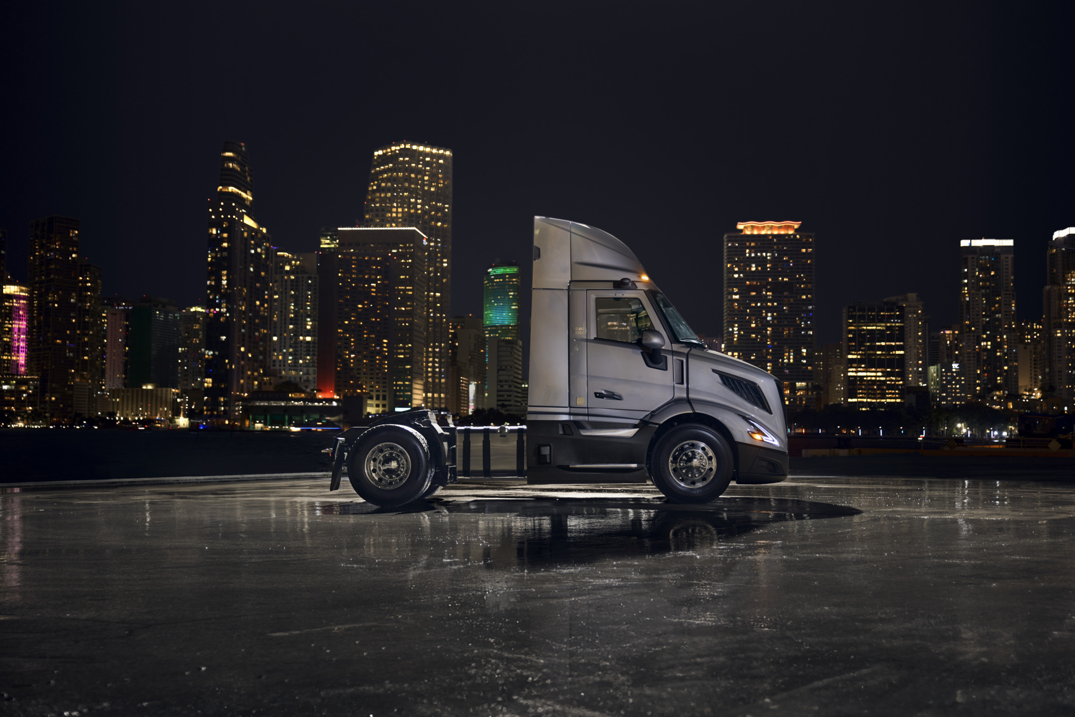

**CAPTION**: The all-new Volvo VNR will debut to the industry in the Volvo Trucks North America booth #901 at TMC in Nashville, March 10-13, 2025.

**CAPTION**: With its seamless blend of driver-focused technology, ergonomic design, and comfort-enhancing features, the all-new Volvo VNR delivers an environment that helps drivers “own the day”—whether they are maneuvering through city streets, making regional runs, or settling in for a night on the road.

**CAPTION**: The all-new Volvo VNR is Volvo’s most versatile truck ever built, designed to create an efficient, comfortable, and highly functional working environment for drivers—

enabling them to “own the day” in ways they never thought possible.

March 11, 2025

To learn more about Volvo Trucks North America and the all-new Volvo VNR, visit the company [website](https://www.volvotrucks.us/).

High-resolution images associated with this press release and others are available at[https://press.volvotrucks.us/.](https://press.volvotrucks.us/)

For further information, please contact:

Kyle Zimmerman

Public Relations Manager, Volvo Trucks North America

[kyle.zimmerman@volvo.com](mailto:kyle.zimmerman@volvo.com)

(704) 677-9757

Volvo Trucks North America, headquartered in Greensboro, North Carolina, is one of the leading heavy-duty truck manufacturers in North America. Its Uptime Services commitment is delivered by a network of nearly 400 authorized dealers across North America and the 24/7 Volvo Trucks Uptime Center. Every Volvo truck is assembled in the Volvo Trucks New River Valley manufacturing facility in Dublin, Virginia, which meets the internationally recognized ISO 9001 standard for quality, 14001 standard for environmental care and holds a dual ISO 50001/Superior Energy Performance certification at the platinum level, indicating a sustained excellence in energy management. Volvo Trucks North America provides complete transport solutions for its customers, offering a full range of diesel, alternative-fuel and all-electric vehicles, and is part of the Volvo Trucks global organization.

Volvo Trucks supplies complete transport solutions for discerning professional customers with its full range of medium- and heavy-duty trucks. Customer support is provided via a global network of dealers with 2,200 service points in about 130 countries. Volvo trucks are assembled in 12 countries across the globe. In 2024 approximately 134,000 Volvo trucks were delivered worldwide. Volvo Trucks is part of the Volvo Group, one of the world’s leading manufacturers of trucks, buses, construction equipment and marine and industrial engines. The group also provides complete solutions for financing and service. Volvo Trucks’ work is based on the core values of quality, safety and environmental care.