P R E S S R E L E A S E
Volvo Trucks Showcases Next-Generation Technology and Solutions at ACT Expo 2024, Setting New Standards in Transportation Innovation

Volvo Trucks North America will showcase a variety of next-generation technology and solutions at the Advanced Clean Transportation (ACT) Expo at the Las Vegas Convention Center on May 20-23, 2024. Attendees will see the all-new Volvo VNL, designed to change everything, and reshape the Class 8 trucking landscape with its cutting-edge technology, fuel efficiency, safety, and unprecedented customer value. The all-new Volvo VNL will be the platform for all future propulsion technologies such as battery-electric, fuel cell, and internal combustion engines powered by renewable fuels, including hydrogen. The active safety features introduced in the all-new Volvo VNL and the first 24-volt electrical architecture in North America will redefine the standard for trucking, including the commercialization of fully autonomous trucks.

The Volvo booth will showcase the all-new Volvo VNL 860 flagship sleeper for the first time and a Volvo VNR Electric truck currently deployed by 4 Gen Logistics. The booth will also feature innovative technology from Volvo Penta, Volvo Construction Equipment, and Volvo Autonomous Solutions, highlighting Volvo’s ‘Together Towards Zero’ comprehensive approach to driving innovation and decarbonization across various sectors of the transportation industry.

A press conference will be held on Monday, May 20, at 5:35pm PT at the Volvo booth #2929. The company will share insights on the all-new Volvo VNL that is leading a transformation of the North American trucking industry and will also provide updates on new deployments of the Volvo VNR Electric and key partnerships to develop accessible charging solutions as the company continues to expand the electromobility ecosystem. Volvo Construction Equipment will join the press conference to brief the media on its latest developments in zero-emission solutions for off-road applications. During the press conference, Volvo Autonomous Solutions will pull the cover off its next-generation truck, the next step towards launching fully autonomous Class 8 trucks commercially in North America. Volvo Autonomous Solutions will welcome members of the press as well as show attendees to a walk-around immediately following the press conference.

“Our all-new Volvo VNL is on display at ACT Expo, showcasing the striking aerodynamics and powertrain enhancements that improve fuel efficiency by up to 10% as well as the industry leading safety features and cutting-edge technologies that reshape the North American trucking industry. These innovations also pave the way for the all-new Volvo VNL to be the platform for all future technologies and propulsion systems. We are excited to be joined in the booth by our colleagues from Volvo Construction Equipment, Volvo Autonomous Solutions, Volvo Penta and Volvo Financial Services. ‘Together Towards Zero’ underscores our combined dedication to driving technological advancements across many sectors to shape a sustainable future,” said Peter Voorhoeve, president, Volvo Trucks North America. “The tremendous growth of ACT Expo in the last several years is a testament to the investment that is being made at every level to develop and deploy advanced vehicle technologies and clean fuels. Our presence this year will display how we are approaching the future from every direction.”

A Volvo VNR Electric 6x2 tractor, currently operated by 4 Gen Logistics will be on display in Volvo Trucks’ booth and is equipped with a six-battery-pack configuration, 455 hp and 4,051 lb.-ft. of torque, and two-speed I-Shift automated manual transmission. 4 Gen Logistics operates 41 Volvo VNR Electric trucks that make daily trips in the Inland Empire and between the Port of Long Beach and 4 Gen Logistics’ headquarters in Rialto, California.

Volvo Penta, a supplier of engines and complete power systems, will highlight its partnership with UtilityInnovation Group (UIG) by displaying UIG's modular, scalable battery energy storage systems. These units, powered by Volvo Penta's battery energy storage subsystem offering, deliver the flexibility to support both mobile charging and stationary power needs. In addition, Volvo Penta will showcase the company's electric driveline solution that is quickly gaining momentum in a variety of off-road machines and applications. By collaborating closely with OEM partners, Volvo Penta's aim is to collaborate on efficient, cost-effective, reliable, and high-performing power solutions and drive the transition towards a sustainable future.

Volvo Construction Equipment will showcase a EC230 Electric excavator that is representative of the leadership position Volvo Construction Equipment has taken in bringing zero-emission solutions to off-road applications. The EC230 Electric is commercially available now in North America. Volvo Construction Equipment will also display two new Volvo-branded mobile charging units for off-grid fast-charging of its compact and full-size electric machines.

Speaking engagements at ACT Expo 2024 among the Volvo executive team include:

- May 20, 8:45 – 9:00am - New Frontiers for Low and Zero Emissions Vehicles: Off-Road – Session Keynote - Darren Tasker, vice president of industrial, Volvo Penta

- May 20, 2:15 - 2:45pm - Mainstage Opening Keynote: Global Trends and OEM Perspectives - Roger Alm, president, Volvo Trucks

- May 20, 5:35 – 6:00pm – Join Volvo for a press announcement in booth #2929

- May 21, 9:45 - 11:00am - Mainstage: CEO Roundtable on Scaling Vehicle Electrification - Peter Voorhoeve, president, Volvo Trucks North America

- May 22, 3:30 - 4:45pm - Breakout Session: Public Service Fleets at the Cutting Edge - Dr. Ray Gallant, vice president, sustainability and productivity services, Volvo Construction Equipment
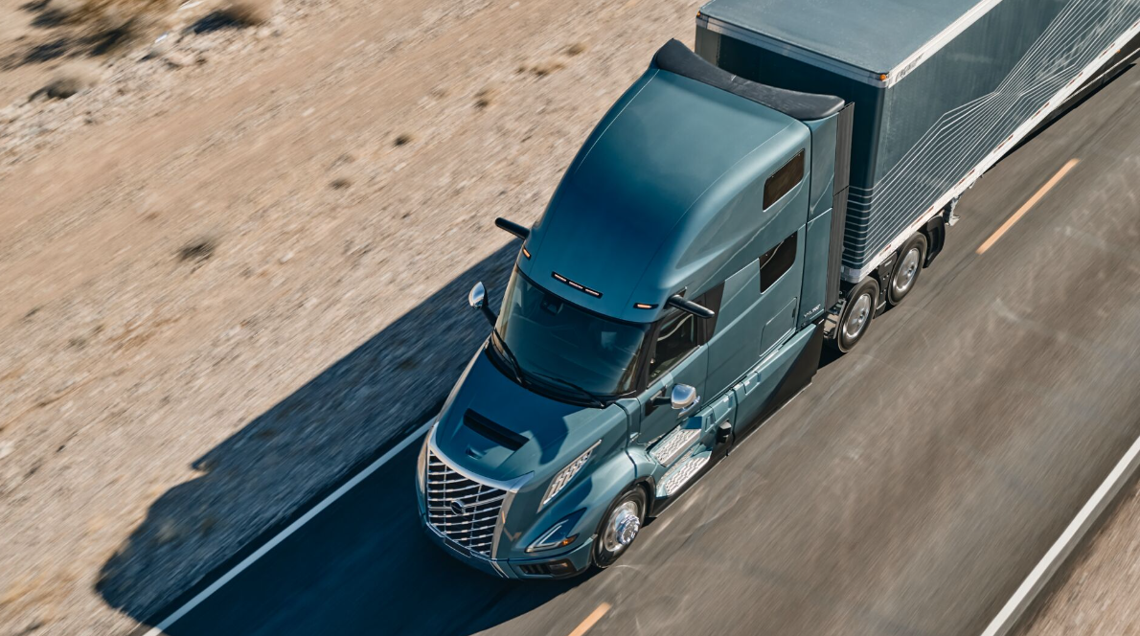

CAPTION: The all-new Volvo VNL 860 74-inch high-roof sleeper, featuring the Ultimate interior and exterior trim packages, will be showcased for the first time at the Volvo booth #2929 at ACT Expo in Las Vegas, May 20-23, 2024.

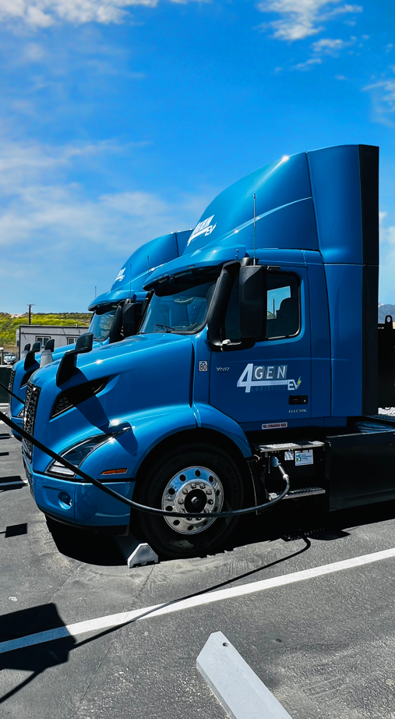

CAPTION: A Volvo VNR Electric truck operated by 4 Gen Logistics will be showcased in the Volvo booth #2929 at ACT Expo in Las Vegas, May 20-23, 2024.

May 9, 2024

To learn more about Volvo Trucks North America, visit the company website.

High-resolution images associated with this press release and others are available at https://press.volvotrucks.us/

For further information, please contact:

Kyle Zimmerman
Public Relations Manager, Volvo Trucks North America
kyle.zimmerman@volvo.com
(704) 677-9757

Volvo Trucks North America, headquartered in Greensboro, North Carolina, is one of the leading heavy-duty truck manufacturers in North America. Its Uptime Services commitment is delivered by a network of nearly 400 authorized dealers across North America and the 24/7 Volvo Trucks Uptime Center. Every Volvo truck is assembled in the Volvo Trucks New River Valley manufacturing facility in Dublin, Virginia, which meets the internationally recognized ISO 9001 standard for quality, 14001 standard for environmental care and holds a dual ISO 50001/Superior Energy Performance certification at the platinum level, indicating a sustained excellence in energy management. Volvo Trucks North America provides complete transport solutions for its customers, offering a full range of diesel, alternative-fuel and all-electric vehicles, and is part of the Volvo Trucks global organization.

Volvo Trucks supplies complete transport solutions for discerning professional customers with its full range of medium- and heavy-duty trucks. Customer support is provided via a global network of dealers with 2,200 service points in about 130 countries. Volvo trucks are assembled in 12 countries across the globe. In 2023 approximately 145,000 Volvo trucks were delivered worldwide. Volvo Trucks is part of the Volvo Group, one of the world’s leading manufacturers of trucks, buses, construction equipment and marine and industrial engines. The group also provides complete solutions for financing and service. Volvo Trucks’ work is based on the core values of quality, safety and environmental care.

