P R E S S R E L E A S E

Volvo’s Vision of ‘Together Towards Zero’ Takes Center Stage at ACT Expo 2025

Volvo Trucks North America will showcase their latest technologies and solutions at the Advanced Clean Transportation (ACT) Expo at the Anaheim Convention Center from April 28 to May 1, 2025. The booth (#4537) will spotlight innovative solutions including the all-new Volvo VNL, which has set the industry standard in fuel efficiency, safety, and total cost of ownership, and can today be run on renewable diesel. Additionally, Volvo Trucks will highlight their leading position in electromobility with the Volvo VNR Electric. Attendees are invited to engage with Volvo experts to learn about the commercially available solutions designed to continue the journey towards zero emissions and zero accidents.

Volvo Trucks will showcase the all-new Volvo VNL 860 flagship sleeper and a Volvo VNR Electric truck currently in operation with Penske Truck Leasing, as well as the Volvo VNL Autonomous, a fully redundant self-driving truck which is already pulling commercial loads in Texas. The ‘World of Volvo’ themed booth will also feature innovative technology and equipment from Volvo Penta, Volvo Construction Equipment, and Volvo Autonomous Solutions, reinforcing Volvo’s comprehensive ‘Together Towards Zero’ strategy to advance decarbonization across both on- and off-road applications.

“We are proud to showcase our total transportation solutions as we advance our vision of a world with zero emissions and zero accidents. 'Together Towards Zero' reflects the Volvo vision toward a safer and more sustainable future as we continue to move towards our ambition of 100% zero emissions transport by 2040,” said Peter Voorhoeve, president, Volvo Trucks North America. “This collective commitment across the Volvo Group is essential to accelerating the transition to safer and cleaner transportation solutions across every sector.”

Designed for the future, the all-new Volvo VNL will be the platform to support all propulsion technologies, from battery-electric and fuel cells to internal combustion engines running on renewable fuels like hydrogen. The all-new Volvo VNL also introduced active safety features and North America’s first 24-volt electrical architecture – key innovations that are redefining the standard for trucking and enabling the commercialization of fully autonomous trucks. The ​most connected truck ever built by Volvo Trucks, the all-new Volvo VNL offers advanced connectivity solutions that reduce total cost of ownership while enhancing customer satisfaction and driver productivity.

The Volvo booth will showcase the Volvo VNL Autonomous—a fully redundant autonomous truck engineered for industrialization and seamless integration with various self-driving technologies.

**Key Volvo Events at ACT Expo 2025**

**State of Sustainable Fleets 2025 Market Brief**  
Tuesday, April 29, 12:45 PM PT – Volvo booth (#4537)  
Voorhoeve will join representatives from TRC Companies, Penske Truck Leasing, and Chevron to discuss key findings from this industry-leading report on clean transportation technologies. Volvo Trucks is a title sponsor of the annual report.

**Press Conference: Together Towards Zero**   
Tuesday, April 29, 11:25 AM PT – Volvo booth (#4537)  
Voorhoeve will moderate a panel with leaders from Volvo Trucks, Volvo Construction Equipment, Volvo Penta, and Volvo Autonomous Solutions.

**Volvo Speakers at ACT Expo 2025**

**Monday, April 28**

* 12:30 - 1:45 pm: Software-Defined Vehicles Unlocking Unmatched Fleet Performance - Nicole Portello, SVP and Chief Digital Officer, Volvo Group North America
* 12:30 - 1:45 pm: Proven Technologies for Superior Economic and Environmental Performance - Jared Ruiz, Regional VP, West Region, Volvo Trucks North America
* 12:45 - 1:45 pm: The Drive for Using Hydrogen in Internal Combustion Engines - Mehdi Fehran, SVP Powertrain Engineering, Volvo Group

**Tuesday, April 29**

* 9:15 am – **Mainstage Keynote: Lars Stenqvist, CTO, Volvo Group:** Stenqvist will highlight Volvo’s advancements in hydrogen internal combustion engines, connected vehicle solutions, and battery-electric and autonomous technologies.

**Wednesday, April 30**

* 12:50 - 1:00 pm: Expo Hall Theater - Real World Applicants of Battery Energy Storage Systems (BESS) - Darren Tasker, Volvo Penta
* 1:30 - 2:45 pm: Agriculture & Construction Sector: Building Towards Electrification - Dr. Ray Gallant, VCE

**Thursday, May 1**

* 10:45 - 11:10 am: Charging at Scale: How Public and Private Infrastructure Will Power Future EV Fleets - Kristina Nilsson, Senior VP, Charging and Infrastructure Solutions, Volvo Energy

**CAPTION**: A Volvo VNR Electric truck operated by Penske Truck Leasing will be showcased in the Volvo booth #4537 at ACT Expo in Anaheim, California, April 28-May 1, 2025.

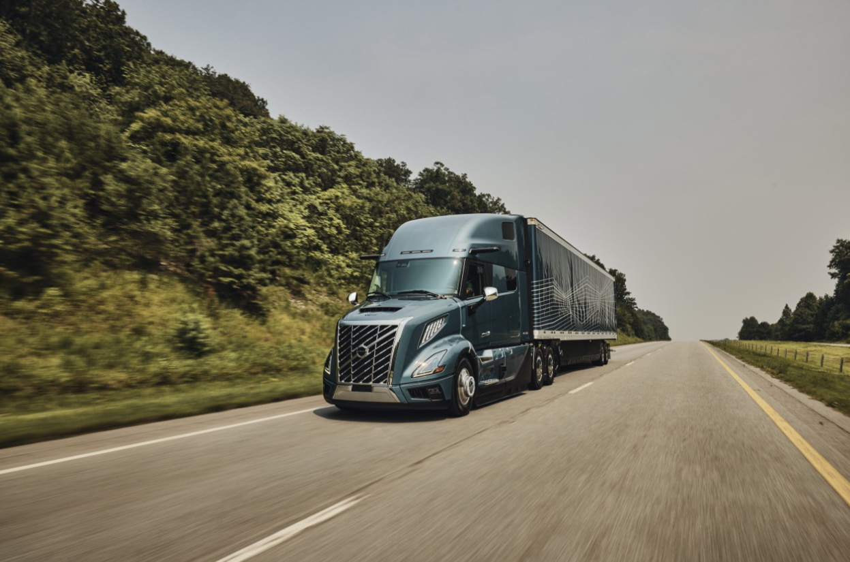

**CAPTION**: The all-new Volvo VNL 860 74-inch high-roof sleeper, featuring the Ultimate interior and exterior trim packages, will be showcased in the Volvo booth #4537 at ACT Expo in Anaheim, California, April 28-May 1, 2025.

**CAPTION**: A Volvo VNL Autonomous, integrated with the Aurora Driver will be showcased in the Volvo booth #4537 at ACT Expo in Anaheim, California, April 28-May 1, 2025.

April 14, 2025

To learn more about Volvo Trucks North America, visit the company [website](https://www.volvotrucks.us/).

High-resolution images associated with this press release and others are available at<https://press.volvotrucks.us/> https://press.volvotrucks.us/.

For further information, please contact:

Kyle Zimmerman

Public Relations Manager, Volvo Trucks North America

[kyle.zimmerman@volvo.com](mailto:kyle.zimmerman@volvo.com)

(704) 677-9757

Volvo Trucks North America, headquartered in Greensboro, North Carolina, is one of the leading heavy-duty truck manufacturers in North America. Its Uptime Services commitment is delivered by a network of nearly 400 authorized dealers across North America and the 24/7 Volvo Trucks Uptime Center. Every Volvo truck is assembled in the Volvo Trucks New River Valley manufacturing facility in Dublin, Virginia, which meets the internationally recognized ISO 9001 standard for quality, 14001 standard for environmental care and holds a dual ISO 50001/Superior Energy Performance certification at the platinum level, indicating a sustained excellence in energy management. Volvo Trucks North America provides complete transport solutions for its customers, offering a full range of diesel, alternative-fuel and all-electric vehicles, and is part of the Volvo Trucks global organization.

Volvo Trucks supplies complete transport solutions for discerning professional customers with its full range of medium- and heavy-duty trucks. Customer support is provided via a global network of dealers with 2,200 service points in about 130 countries. Volvo trucks are assembled in 12 countries across the globe. In 2024 approximately 134,000 Volvo trucks were delivered worldwide. Volvo Trucks is part of the Volvo Group, one of the world’s leading manufacturers of trucks, buses, construction equipment and marine and industrial engines. The group also provides complete solutions for financing and service. Volvo Trucks’ work is based on the core values of quality, safety and environmental care.