EMBARGOED UNTIL May 20, 2024 AT 5:35PM PT

P R E S S R E L E A S E
Volvo Trucks North America and Volvo Financial Services Launch Volvo on Demand to Accelerate Battery-Electric Vehicle Adoption
Volvo Trucks North America (VTNA) and Volvo Financial Services (VFS) have joined forces to form Volvo on Demand, a collaborative initiative to change and lead the industry in the Truck-as-a-Service (TaaS) business model. Using 25 Class 8 Volvo VNR Electric trucks, Volvo on Demand was designed as an innovative solution to simplify the acquisition and reduce the major upfront investment in battery-electric vehicles. Volvo on Demand provides qualified customers with flexible term options as short as 12 months and includes Volvo Trucks’ industry leading Gold Contract and the option to bundle vehicle insurance for physical damage and collision, route planning and optimization guidance, as well as consultation to find the best charging solution and incentives that might be available. Volvo on Demand is the next way to leverage the established electromobility ecosystem tailored for Volvo VNR Electric trucks in North America.

“Volvo on Demand is the easiest way for customers to add a battery-electric truck to their fleet by providing the ability to test the technology and understand the requirements to operate an electric fleet without a substantial upfront investment,” said Charles Carter, vice president, services and solutions, Volvo Financial Services. “Volvo on Demand offers peace of mind to customers who are just beginning their electromobility journey, managing the unknowns and uncertainties of how to best run and scale electric trucks in their operations. We see this solution being exceptionally beneficial to many segments including drayage, regional haul, last mile and smaller fleets, who are tasked with delivering more sustainable transportation solutions for their customers.”

With Volvo on Demand, customers can minimize the upfront investment associated with transitioning to battery-electric trucks and free up credit lines that can be used towards business growth. A competitive mileage rate throughout the contract term provides flexibility, with a single monthly invoice encompassing all selected services, charging hardware and insurance. VFS has kickstarted the Volvo on Demand program with 25 Volvo VNR Electric trucks, including 20 6x4 tractors with the six-battery configuration and five 4x2 tractors with the four-battery configuration.

The Class 8 Volvo VNR Electric is a zero-tailpipe emission solution which is an ideal fit for local and regional distribution, pickup and delivery, and food and beverage distribution. The battery-electric truck has a range of up to 275 miles (with a six-battery configuration) and features a dedicated battery thermal management system to maintain ideal battery temperatures. With a 250 kWh charge rate, the truck can achieve an 80% charge in as little as 90 minutes for the six-battery package and 60 minutes for the four-battery package. The Volvo VNR Electric truck provides instant torque, and smooth acceleration and deceleration delivering optimal performance and drivability and zero-tailpipe emissions. The electric driveline also reduces vibration and in-cab noise compared to traditional trucks which results in a more comfortable and relaxing driving experience.

Volvo on Demand is being launched in the United States in areas with a nearby Volvo Trucks Certified Electric Vehicle (EV) dealership equipped to provide comprehensive support, including preventative maintenance, service, and charging facilities to maximize customer uptime. Volvo Trucks Certified EV Dealers have onsite technicians who have been comprehensively trained to service the VNR Electric safely and efficiently. With 59 locations across 31 states and Canadian provinces in North America completing the rigorous certification program, Volvo Trucks provides a robust ecosystem to facilitate the adoption of heavy-duty battery-electric vehicles.

“Today we have customers who’ve successfully deployed the VNR Electric and are continuing to seek ways to scale their operations to include more of these trucks,” said Jared Ruiz, regional vice president, Volvo Trucks North America. “We have a number of customers who have expressed interest in adding the VNR Electric to their operation but want to understand how it will fit within their specific applications. With Volvo on Demand through VFS, they can gain valuable experience before making large upfront capital investments. With Volvo on Demand customers can get a single truck or a few trucks with portable 50 kWh chargers to gain real world experience while making plans to scale, including accounting for potential lead times on charging infrastructure installation, with flexible payment terms. We see this program as the next evolution in scaling electromobility solutions by offering unmatched financial flexibility to our customers.”

Charging infrastructure remains one of the biggest hurdles fleets must overcome as they seek to deploy zero emission vehicles. In 2023, Volvo Trucks introduced two programs to streamline the electromobility transition for fleet managers, allowing them to focus on their daily business operations while a dedicated team works on their infrastructure installation and energization.

The Turnkey Solutions program manages all aspects of the process to develop charging infrastructure and covers charging hardware, software, permitting, installation, all the interaction with the utility companies, and maintaining charging equipment. Through the Vendor Direct Shipping program, customers and dealers can order equipment through the dealership parts portal. Volvo Trucks sales teams can assist customers with the process and determine the type of charger best equipped for the application.

VFS continues to finance charging infrastructure as part of the total electromobility transportation solution and both the Vendor Direct Shipping and the Turnkey Solution programs are options that enable qualified customers to bundle charging solutions with financing or leasing solutions for battery-electric trucks.

Volvo Financial Services is the global finance arm of the Volvo Group, one of the world's leading manufacturers of trucks, buses, construction equipment and marine and industrial engines. Volvo Financial Services supports the Volvo Group's brands with a full range of offerings to customers and dealers, including financing, leasing, and insurance solutions.

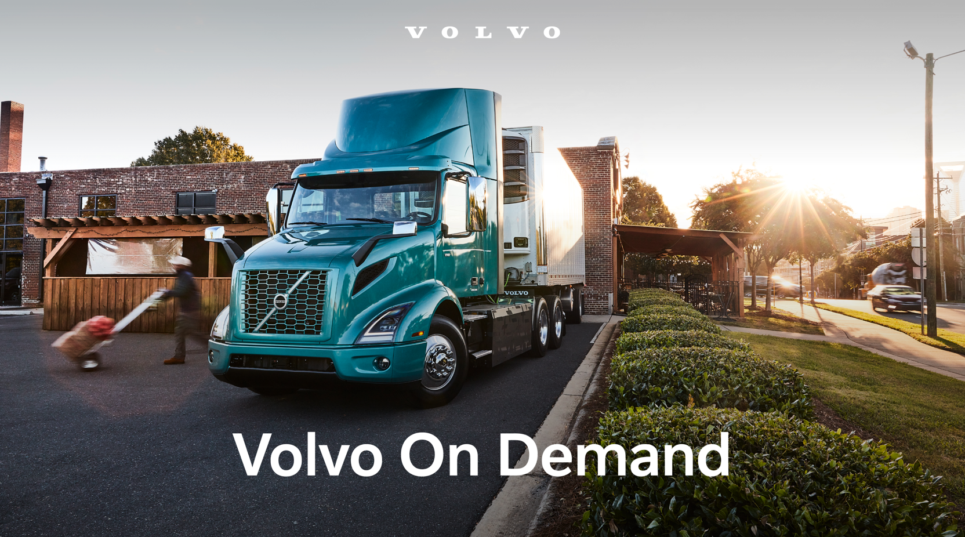

CAPTION: Volvo Trucks North America and Volvo Financial Services are collaborating on Volvo on Demand, a joint project to accelerate battery-electric vehicle adoption and redefine the Truck-as-a-Service (TaaS) business model using 25 Class 8 Volvo VNR Electric trucks.

May 20, 2024

To learn more about Volvo Trucks North America and the Volvo VNR Electric, visit the company website.

High-resolution images associated with this press release and others are available at https://press.volvotrucks.us/.

For further information, please contact:

Kyle Zimmerman
Public Relations Manager, Volvo Trucks North America
kyle.zimmerman@volvo.com
(704) 677-9757

Volvo Trucks North America, headquartered in Greensboro, North Carolina, is one of the leading heavy-duty truck manufacturers in North America. Its Uptime Services commitment is delivered by a network of nearly 400 authorized dealers across North America and the 24/7 Volvo Trucks Uptime Center. Every Volvo truck is assembled in the Volvo Trucks New River Valley manufacturing facility in Dublin, Virginia, which meets the internationally recognized ISO 9001 standard for quality, 14001 standard for environmental care and holds a dual ISO 50001/Superior Energy Performance certification at the platinum level, indicating a sustained excellence in energy management. Volvo Trucks North America provides complete transport solutions for its customers, offering a full range of diesel, alternative-fuel and all-electric vehicles, and is part of the Volvo Trucks global organization.

Volvo Trucks supplies complete transport solutions for discerning professional customers with its full range of medium- and heavy-duty trucks. Customer support is provided via a global network of dealers with 2,200 service points in about 130 countries. Volvo trucks are assembled in 12 countries across the globe. In 2023 approximately 145,000 Volvo trucks were delivered worldwide. Volvo Trucks is part of the Volvo Group, one of the world’s leading manufacturers of trucks, buses, construction equipment and marine and industrial engines. The group also provides complete solutions for financing and service. Volvo Trucks’ work is based on the core values of quality, safety and environmental care.

