Continental Acoustic Vehicle Alerting System (AVAS) Provides Audible Warning for Near-Silent EVs
- Allows OEMs to create unique, brand-specific sounds for their vehicles
- Meets UN R138.01 (EU, China) and FMVSS 141 (USA) and automotive quality standards

Anaheim, CA, April 28, 2025—Continental offers an Acoustic Vehicle Alerting System (AVAS) for Electric Vehicle manufacturers. This system meets the major international safety standards and lets manufacturers customize its sounds.

For on-road, off-road, and indoor vehicle applications
Many countries have required AVAS for all new electric vehicles since 2019. The AVAS system generates sound for nearly silent electric vehicles, improving the safety of vulnerable pedestrians, cyclists, and animals. The same acoustic safety principle applies to off-road vehicles and vehicles operating in warehouses, exhibition halls, and other indoor spaces.

Different sounds based on specific events
In the Continental AVAS, artificial vehicle sounds are generated using a loudspeaker with sound volume produced in proportion to vehicle parameters such as speed and gear. Just as traditional vehicles often make a slightly different sound when reversing, the Continental AVAS system can also provide a unique reversing sound to warn people that the vehicle is moving backward.

Off-the-shelf convenience – yet fully customizable
Nate Stehman, Project Manager for Continental Commercial and Special Vehicles (CSV), North America, states, “We have a lightweight, off-the-shelf AVAS that can be customized to meet any OEM’s needs. Continental AVAS can be the solution from a simple, low-cost implementation that can withstand off-highway use to a fully customized version with multiple sound cues for various vehicle motions and events.”

For more information, contact: salessupport-us@continental.com

Continental develops pioneering technologies and services for sustainable and connected mobility of people and their goods. Founded in 1871, the technology company offers safe, efficient, intelligent, and affordable solutions for vehicles, machines, traffic, and transportation. In 2023, Continental generated sales of €41.4 billion and currently employs around 200,000 people in 56 countries and markets.
Drawing on more than 120 years of cooperation with vehicle manufacturers, Continental offers a broad range of spare parts in OEM quality for the aftermarket. Under brands like Continental, ATE, VDO, REDI-Sensor, Autodiagnos, Uniroyal, Semperit, and GALFER, the technology company manufactures tens of thousands of products, including tires, brakes, drive components and thermal management components. It also provides diagnostic solutions, tools and services for repair shops. Continental is one of the most important suppliers in the independent automotive aftermarket.
Press contact:

Nate Stehman
Project Manager, PMP
Commercial and Special Vehicles (CSV), North America
Autonomous Mobility (AM)
Automotive
Tel: 484-705-1871
Email: nate.stehman@continental-corporation.com

Image and caption
[Image: Continental Acoustic Vehicle Alerting System (AVAS).jpg]

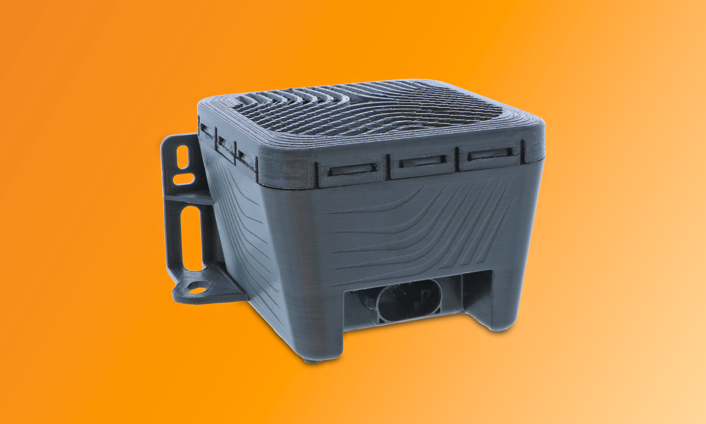

[Caption]
The Continental AVAS provides warning sounds for nearly silent EVs

CO9190/18-2025

