Continental MultiViu Compact 7 Digital Display Stays Readable, Even in Direct Sunlight
- 7-inch TFT display features optional touch function, modular architecture for easy customization
Anaheim, CA, April 28, 2025 – Continental offers the MultiViu® Compact 7 (MVC7) as a flexible, full digital display for commercial vehicle designers. The tablet-like design features a 7” display with optional touchscreen availability, and the bright TFT screen allows for excellent readability, even in direct sunlight. The screen can be used in horizontal and vertical orientations and display different information in each orientation.
The MVC7 features analog and digital inputs and outputs, an integrated video interface, and SAE J1939 CAN compatibility. The display offers modular architecture for easy adaptation to specific vehicle software needs. Product customization goes beyond the logical and graphical human-machine interface, extending to tailored telltales and branding elements. The MVC7 screen includes 24 standard backlit telltales that can provide the driver with system feedback and diagnostic alerts.
“The MVC7 is a platform-independent, ready-to-use solution for lower volume vehicle manufacturers,” notes Edwin Betancourt, Continental Product Manager. “It’s an affordable unit that delivers all necessary information and diagnostics on a screen that is easy to read and fits in a small footprint.”
The MultiViu Compact 7 is a robust display with scratch-resistant mineral glass and IP65 protection against dust and water intrusion. It is compatible with 12V and 24V and can operate from -22F to 158F.
For more information, visit: MultiViu Compact 7 Digital Display
or contact: salessupport-us@continental.com

Continental develops pioneering technologies and services for sustainable and connected mobility of people and their goods. Founded in 1871, the technology company offers safe, efficient, intelligent, and affordable solutions for vehicles, machines, traffic, and transportation. In 2023, Continental generated sales of €41.4 billion and currently employs around 200,000 people in 56 countries and markets.
Drawing on more than 120 years of cooperation with vehicle manufacturers, Continental offers a broad range of spare parts in OEM quality for the aftermarket. Under brands like Continental, ATE, VDO, REDI-Sensor, Autodiagnos, Uniroyal, Semperit, and GALFER, the technology company manufactures tens of thousands of products, including tires, brakes, drive components and thermal management components. It also provides diagnostic solutions, tools and services for repair shops. Continental is one of the most important suppliers in the independent automotive aftermarket.
Press contact:

Nate Stehman
Project Manager, PMP
Commercial and Special Vehicles (CSV), North America
Autonomous Mobility (AM)
Automotive
Tel: 484-705-1871
Email: nate.stehman@continental-corporation.com

Image and caption
[Image: Continental MultiViu Compact 7.jpg]

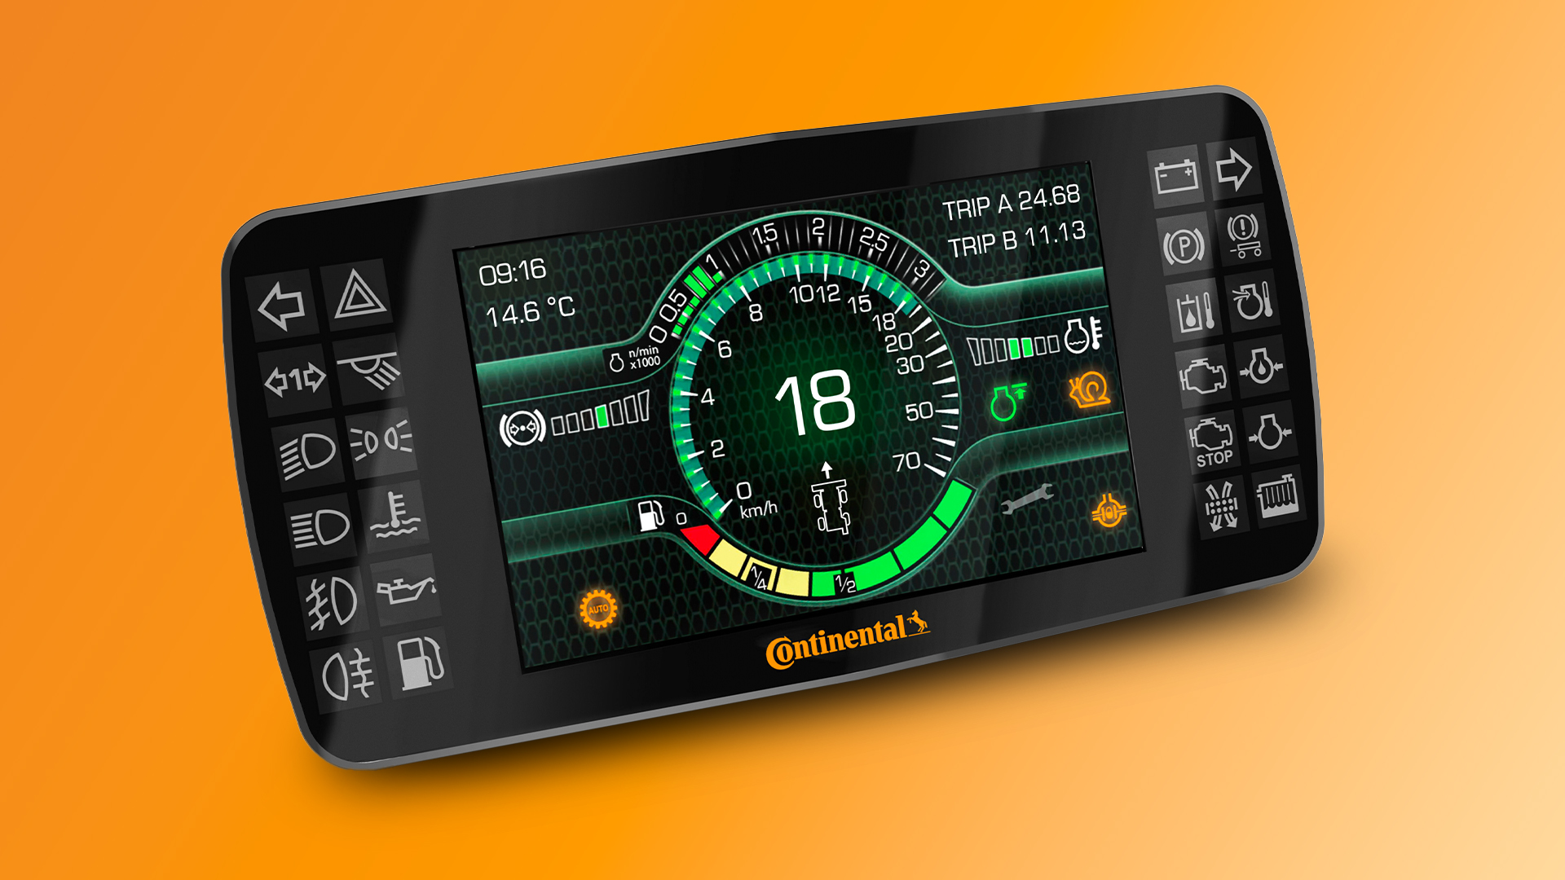

[Caption]
The Continental MultiViu Compact 7 delivers excellent readability, even in direct sunlight.

CO9185/118-25

