Continental MultiViu Professional 12 2nd Generation Digital Instrumentation Display Contributes to a Versatile Human-Machine-Interface (HMI) System
- Fully programmable, 12-inch touchscreen Digital Instrument Cluster is ready off-the-shelf
Anaheim, CA, April 28, 2025 – Continental offers the MultiViu® Professional 12 (MVP12) GEN 2 instrument cluster display for a wide range of vehicles, including buses and trucks. This state-of-the-art, multi-purpose information display offers commercial vehicle designers and manufacturers maximum design freedom for creative and functional instrumentation options, including animation and video implementation. This off-the-shelf display can be easily integrated into existing vehicle architectures.
The MultiViu Professional 12 GEN 2 is fully programmable and easily adapts to individual customer requirements. This innovative cluster can mimic traditional analog gauges or show animated text, scales, bar charts, diagnostic messages, camera feed, on-screen tell-tales, and 14 physical tell-tale symbols. It features a high-contrast, mineral glass with anti-glare, anti-reflection, and anti-finger-print full-color TFT display with a 12.3-inch programable touchscreen. The display’s graphics are developed using model-based programming software that allows designers to create a unique look and feel for the display.
The MVP12 features 4 CAN, 2 LIN, and Ethernet for DoIP interfaces, allowing vehicle designers to customize the display to their specifications. The display also features digital and analog inputs, three analog video inputs, a digital video input and up to 32 sound-programmable internal speaker. The MVP12 also features a highly reliable, ASIL-B compliant tell-tale module. The MVP12 is a durable solution for commercial vehicle cockpits, with the front of display rated at IP54 and the rear of display at IP20. The display can be operated on both 12V and 24V systems. The Continental MVP12 Gen 2 is available in Classic and Modern styles. The Classic style features a plastic bezel housing, while the Modern style delivers a sleek profile with no housing and VESA mounting.
For more information, visit: MultiViu® Professional 12
or contact: salessupport-us@continental.com
Continental develops pioneering technologies and services for sustainable and connected mobility of people and their goods. Founded in 1871, the technology company offers safe, efficient, intelligent, and affordable solutions for vehicles, machines, traffic, and transportation. In 2023, Continental generated sales of €41.4 billion and currently employs around 200,000 people in 56 countries and markets.
Drawing on more than 120 years of cooperation with vehicle manufacturers, Continental offers a broad range of spare parts in OEM quality for the aftermarket. Under brands like Continental, ATE, VDO, REDI-Sensor, Autodiagnos, Uniroyal, Semperit, and GALFER, the technology company manufactures tens of thousands of products, including tires, brakes, drive components and thermal management components. It also provides diagnostic solutions, tools and services for repair shops. Continental is one of the most important suppliers in the independent automotive aftermarket.
Press contact:

Nate Stehman
Project Manager, PMP
Commercial and Special Vehicles (CSV), North America
Autonomous Mobility (AM)
Automotive
Tel: 484-705-1871
Email: nate.stehman@continental-corporation.com

Image and caption
[Image: Continental MVP12 Classic and Modern.jpg]

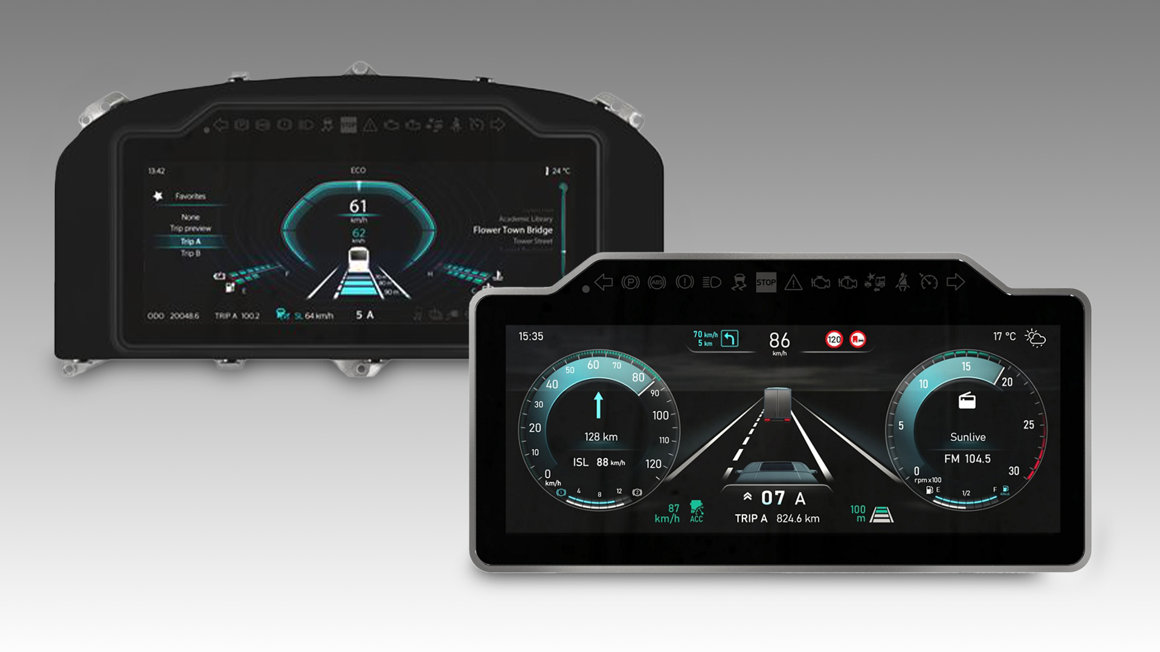

[Caption]
Continental MVP12 off-the-shelf instrument clusters are available in Classic and Modern configurations.

CO9183/18-2025

