The New Continental Multimedia Radio Is Engineered for Commercial Vehicle Requirements
- Supports navigation through Apple CarPlay and Android Auto
- Allows for integration of vehicle cameras

Anaheim, CA, April 28, 2025 – Continental has just introduced a new Multimedia Radio developed specifically for fleet and commercial vehicles. Based on a 1DIN black box, it features a 6.5” TFT touchscreen display with a physical volume knob and four membrane switches for key functions. Both the DIN unit and the screen are designed to withstand the most demanding commercial vehicle and off-highway use.

A broad range of features and file compatibility
Available for 12V applications, with or without CAN J1939, the Continental Multimedia Radio connects with phones via Bluetooth® or can be hardwired via the USB 2.0 Port. The USB port supports 2.1A fast charging for phones. The camera input accepts AHD, CVBS, PAL, and NTSC. Audio file compatibility includes MP3, WMA, AAC, and FLAC, and the system can also play MP4 video and display JPEG images. Compatibility with Apple CarPlay and Android Auto allows access to Siri and Google Assistant and navigation apps from Google, Waze, and Apple. The Continental Multimedia Radio is available with or without DAB/DAB+ Tuner capability, and customer-specific branding and backlighting are also possible. Bluetooth functions include mobile phone connectivity, address book access, and audio input from compatible Bluetooth devices. The display can be used to view pictures in JPG, PNG, BMP, and GIF formats.

Built for commercial applications
Laura Huerst, OEM Project Team Lead for Continental Commercial and Special Vehicles, notes, “The Continental Multimedia Radio includes all the features you would expect from a top-of-the-line consumer multimedia radio, but ours has been engineered to perform under the conditions that fleet and commercial vehicles experience. For vehicles that already incorporate a touchscreen display, our multimedia radio is also available as a black box only, but the standalone box is not certified as a system for the Apple CarPlay and Android Auto like the complete system.”
For more information, visit: Multimedia Radios
or contact: salessupport-us@continental.com

Continental develops pioneering technologies and services for sustainable and connected mobility of people and their goods. Founded in 1871, the technology company offers safe, efficient, intelligent, and affordable solutions for vehicles, machines, traffic, and transportation. In 2023, Continental generated sales of €41.4 billion and currently employs around 200,000 people in 56 countries and markets.
Drawing on more than 120 years of cooperation with vehicle manufacturers, Continental offers a broad range of spare parts in OEM quality for the aftermarket. Under brands like Continental, ATE, VDO, REDI-Sensor, Autodiagnos, Uniroyal, Semperit, and GALFER, the technology company manufactures tens of thousands of products, including tires, brakes, drive components and thermal management components. It also provides diagnostic solutions, tools and services for repair shops. Continental is one of the most important suppliers in the independent automotive aftermarket.
Press contact:

Nate Stehman
Project Manager, PMP
Commercial and Special Vehicles (CSV), North America
Autonomous Mobility (AM)
Automotive
Tel: 484-705-1871
Email: nate.stehman@continental-corporation.com

Image and caption
[Image: Continental Multimedia Radio.jpg]

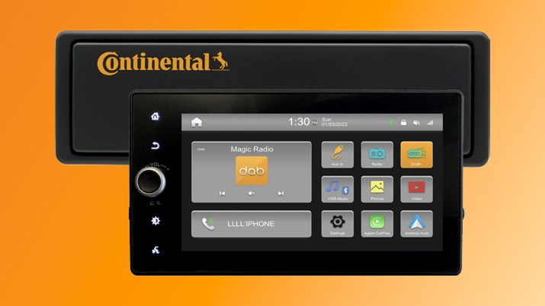

[Caption]
The Continental Multimedia Radio is engineered to meet commercial vehicle requirements.

CO9186/18-2025

