Continental Provides Affordable Solutions for EV Power Management in Medium and Heavy-duty Vehicles
- Portfolio includes Electric Vehicle Charging Controller (EVCC), Intelligent Battery Sensor, and DC/DC Converter
Anaheim, CA, April 28, 2025 – Continental offers EV manufacturers a range of power management solutions for use in fully electric, light, medium, and heavy-duty trucks, buses, and other fleet vehicles. These platform solutions can be rapidly adapted to specific vehicle requirements to help speed development while controlling vehicle costs.

Electric Vehicle Charging Controller
The Continental Electric Vehicle Charging Controller (EVCC) is a main communication controller and provides a logic gateway between the Electric Vehicle Supply Equipment and the vehicle to recharge the high-voltage battery. It initiates and monitors the charging process and can handle all relevant charging standards and design requirements. It is compatible with AC/DC Combined Charging System - CCS1 and CCS2 for European and North American markets. It supports Megawatt Charging System (MCS) or separate pantograph charging capability and, upon customer request, can support CHAdeMO 2.0 / GB/T and ASIL B hardware.

Intelligent Battery Sensor
The Continental Intelligent Battery Sensor (IBS) is a shunt-type sensor that continuously analyzes the status of conventional 12V lead-acid batteries to provide information on parameters such as the state of charge, power ability, and battery aging. It offers a measurement range of 5V to 18V and -1,500 A to 1,500 A. The Continental IBS can be deployed with any standard battery and is mounted directly onto the battery’s negative terminal. The sensor can help warn of possible breakdowns and can also help to extend battery life by 10 to 20 percent through an improved charging strategy. This type of IBS is essential to the reliable operation of automotive start-stop systems.

DC/DC Converter
The Continental Bi-Directional DC/DC Converter is designed to meet the higher power demands of modern commercial vehicles. Today’s on-board network architectures include multiple board nets, and bi-directional DC/DC converters are necessary to bridge these board nets. The Continental DC/DC Converter’s variable design allows power delivery of up to 3.5 kW in buck and 1 kW in boost mode. It supports 12V/24V/48V applications and is IP-rated IP67 + IP6K9K. Connectors include 3x power M8 (CL40, CL30, CL31) and 1x logic 12 Pins (P-CAN H, P-CAN L, CL15). Backed by state-of-the-art cyber security, The Continental DC/DC Converter is an air-cooled, cost-efficient, and reliable solution for transferring energy between board nets.

For more information, visit: Solutions for Electric Commercial Vehicles
or contact: salessupport-us@continental.com

Continental develops pioneering technologies and services for sustainable and connected mobility of people and their goods. Founded in 1871, the technology company offers safe, efficient, intelligent, and affordable solutions for vehicles, machines, traffic, and transportation. In 2023, Continental generated sales of €41.4 billion and currently employs around 200,000 people in 56 countries and markets.
Drawing on more than 120 years of cooperation with vehicle manufacturers, Continental offers a broad range of spare parts in OEM quality for the aftermarket. Under brands like Continental, ATE, VDO, REDI-Sensor, Autodiagnos, Uniroyal, Semperit, and GALFER, the technology company manufactures tens of thousands of products, including tires, brakes, drive components and thermal management components. It also provides diagnostic solutions, tools and services for repair shops. Continental is one of the most important suppliers in the independent automotive aftermarket.
Press contact:

Nate Stehman
Project Manager, PMP
Commercial and Special Vehicles (CSV), North America
Autonomous Mobility (AM)
Automotive
Tel: 484-705-1871
Email: nate.stehman@continental-corporation.com

Image and caption
[Image: Continental platform solutions for EVs.jpg]

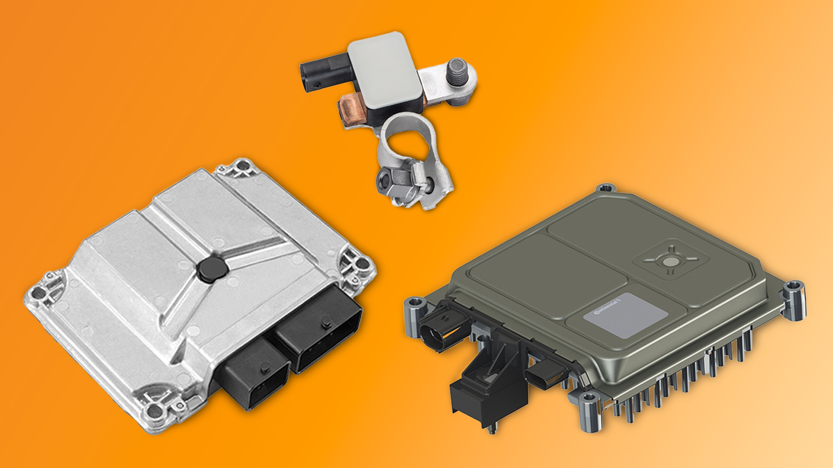

[Caption]
Continental platform solutions for EV power management

CO9183/18-2025

