Continental Demonstrates the ProViu® 360 Camera System In-Booth at the 2025 ACT Show
• Multi-camera system delivers 360-degree bird’s eye view of vehicle
• Reduces risk of accidents, makes driving easier, safer, and less stressful

Anaheim, CA, April 28, 2025 – Continental will feature a live demonstration of the company’s ProViu® 360 Surround View System for commercial vehicles at the 2025 Act Show, Booth # 5044.
The ProViu® 360 camera system combines video feeds from four HD cameras positioned around the vehicle and uses software to ‘stitch’ them into a single view of the vehicle and its surroundings. The live video shows a view that appears to be shot from directly above the vehicle. This eliminates blind spots to make vehicle operations safer, easier, and less stressful. ProViu 360 can be used while the vehicle is in motion or parked. It makes drivers fully aware of everything that’s happening around the vehicle when loading, unloading, or maneuvering through traffic.

The Continental ProViu 360 Surround View System is simple to set up and calibrate. It is compatible with CAN-Bus and other GPIOs and features a flexible software programming tool for easy customization to specific vehicle requirements. The driver can choose to see the 360º view, individual feeds from each camera, or a combination of 360º and individual feeds.

According to Nate Stehman, Project Manager for Continental Commercial and Special Vehicles (CSV), North America, “The ProViu 360 system was engineered as an OE system, but it can also be retrofitted to existing vehicles. The level of added safety it provides cannot be overstated. This system is a true game changer for fleets.”

For more information, visit: ProViu® 360 camera system
or contact: salessupport-us@continental.com

Continental develops pioneering technologies and services for sustainable and connected mobility of people and their goods. Founded in 1871, the technology company offers safe, efficient, intelligent, and affordable solutions for vehicles, machines, traffic, and transportation. In 2023, Continental generated sales of €41.4 billion and currently employs around 200,000 people in 56 countries and markets.
Drawing on more than 120 years of cooperation with vehicle manufacturers, Continental offers a broad range of spare parts in OEM quality for the aftermarket. Under brands like Continental, ATE, VDO, REDI-Sensor, Autodiagnos, Uniroyal, Semperit, and GALFER, the technology company manufactures tens of thousands of products, including tires, brakes, drive components and thermal management components. It also provides diagnostic solutions, tools and services for repair shops. Continental is one of the most important suppliers in the independent automotive aftermarket.
Press contact:

Nate Stehman
Project Manager, PMP
Commercial and Special Vehicles (CSV), North America
Autonomous Mobility (AM)
Automotive
Tel: 484-705-1871
Email: nate.stehman@continental-corporation.com

Image and caption
[Image: Continental ProViu 360 Camera System.jpg]

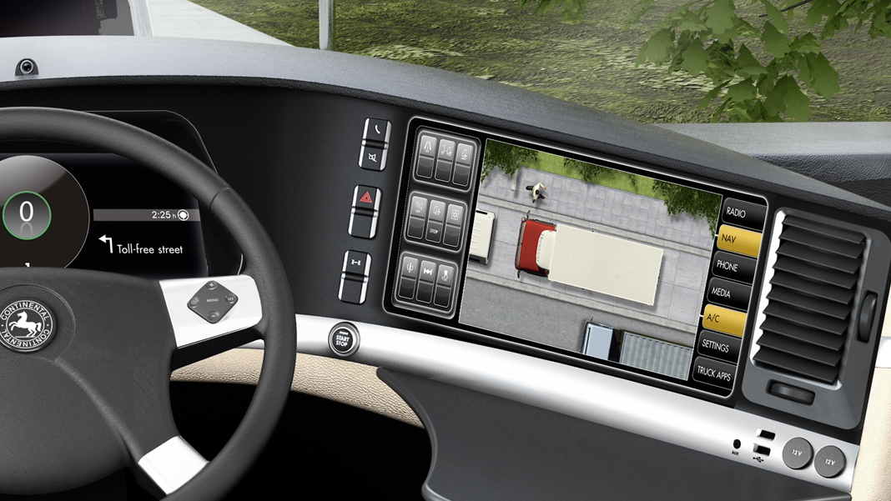

[Caption]
The Continental ProViu® 360 Camera System gives drivers a 360-degree, bird’s eye view around the vehicle.

CO9181/18-2025

