Continental ProViu® Mirror System Replaces Wing Mirrors with HD Video Screens Inside the Vehicle
- ProViu Mirror, Continental’s digital wing camera monitor system helps eliminate blind spots and increases vision at night and in inclement weather.
Anaheim, CA, April 28, 2025—Continental has introduced the ProViu® Mirror System, the first LVDS camera monitor system to replace traditional wing mirrors with high-definition video screens. The system gives vehicle operators a better view of what is happening around their vehicles than conventional mirrors. Fed by video from a single HDR camera, the ProViu® Mirror System helps eliminate blind spots, improves all-around visibility, and increases vision in bad weather and at night. It even suppresses high-beam lights at night, easing the strain on drivers’ eyes.

Multiple advantages over physical mirrors
ProViu® Mirror System can replace wing mirrors for class 2-8 vehicles. Using screens placed inside the vehicle, the system eliminates the physical wing mirrors on the vehicle’s exterior. This provides better aerodynamics, better fuel efficiency, and less noise. It also provides a narrower vehicle width for easier maneuvering in close quarters and eliminates the possibility of damaged wing mirrors.

HDR camera provides superior visibility
The ProViu® Mirror System video feed is provided by a 3-megapixel HDR camera with 1920 x 1536 output and a 60fps frame rate for excellent image quality, even in low-light conditions. Video displays are available in 12.3” and 14.5”, and a configuration for replacing mirrors in class 8 trucks is available via video on one display or two separate 10.1”displays.

According to Jared Hall, Project Manager for Continental Commercial and Special Vehicles (CSV), North America, “Compared to conventional wing mirrors, the ProViu® Mirror System provides better visibility, safer operation, and reduced maintenance. Plus, its availability as an off-the-shelf system makes it easy to integrate into any vehicle.”

For more information, visit: Continental ProViu® Mirror Systems
or contact: salessupport-us@continental.com

Continental develops pioneering technologies and services for sustainable and connected mobility of people and their goods. Founded in 1871, the technology company offers safe, efficient, intelligent, and affordable solutions for vehicles, machines, traffic, and transportation. In 2023, Continental generated sales of €41.4 billion and currently employs around 200,000 people in 56 countries and markets.
Drawing on more than 120 years of cooperation with vehicle manufacturers, Continental offers a broad range of spare parts in OEM quality for the aftermarket. Under brands like Continental, ATE, VDO, REDI-Sensor, Autodiagnos, Uniroyal, Semperit, and GALFER, the technology company manufactures tens of thousands of products, including tires, brakes, drive components and thermal management components. It also provides diagnostic solutions, tools and services for repair shops. Continental is one of the most important suppliers in the independent automotive aftermarket.
Press contact:

Nate Stehman
Project Manager, PMP
Commercial and Special Vehicles (CSV), North America
Autonomous Mobility (AM)
Automotive
Tel: 484-705-1871
Email: nate.stehman@continental-corporation.com

Image and caption
[Image: ProViu digital wing mirror system.jpg]

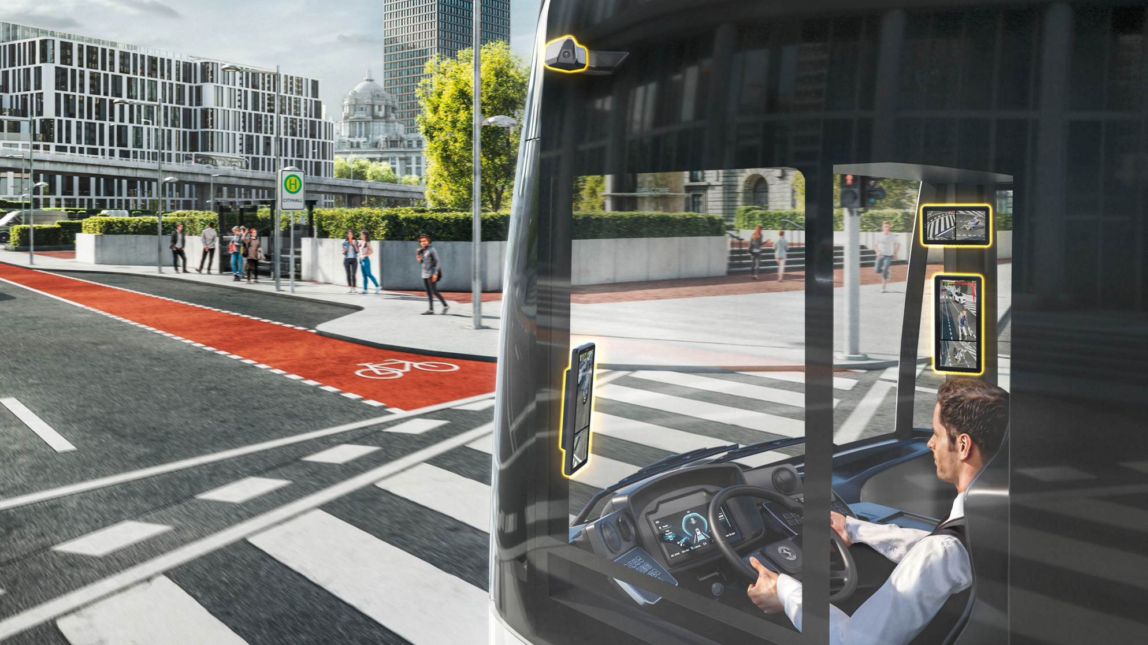

[Caption]
Continental ProViu® Mirror System replaces wing mirrors with video screens inside the vehicle.
CO9189/18-2025

