P R E S S R E L E A S E
EMBARGOED UNTIL MONDAY, MAY 4 AT 6:00PM PT
Volvo and Aurora Launch Autonomous Truck Route to Oklahoma City
Aurora expands freight network and V.A.S. starts operations to customer endpoints
Oklahoma City, OK — May 4, 2026 — Aurora Innovation, Inc. (NASDAQ: AUR) and Volvo Autonomous Solutions (V.A.S.) today announced the expansion of their autonomous freight network with a new 200-mile route between Dallas and Oklahoma City. The expansion marks a significant milestone as V.A.S. begins hauling freight to customer facilities in Oklahoma City with the Volvo VNL Autonomous integrated with the Aurora Driver.
Expanding to New Freight Markets
The Oklahoma City program currently supports trips five days a week in supervised autonomy. By logging hundreds of miles, the Volvo VNL Autonomous integrated with the Aurora Driver supports safer, quicker, and more efficient movement of goods, enabling V.A.S. to provide a premium service.
By operating directly to customer facilities, V.A.S. can reduce the need for drayage moves and additional handoffs, helping remove complexity from the logistics flow. Customers also benefit from Volvo’s extensive dealer network, robust service support, and proven uptime capabilities, helping them adopt autonomous transport while maintaining efficiency.
“Expanding our operations into Oklahoma City and adding customer endpoints is an important step for scaling autonomous transport,” said Sasko Cuklev, Head of On-Road Solutions at Volvo Autonomous Solutions. “Running end-to-end requires a higher level of operational precision and integration, and it further demonstrates how autonomous trucks can operate reliably in real logistics environments. Together with Aurora we are focused on expanding our network and accelerating the adoption of this new and exciting technology.”
“Leveraging our technology to open new routes quickly and efficiently is a core part of our strategy,” said Ossa Fisher, President of Aurora. “Aurora and Volvo are firing on all cylinders and our ability to execute together at scale is clear. As Volvo’s most advanced autonomy partner, we are proud to be the first to deploy the Volvo VNL Autonomous across multiple states.”
The launch also highlights the maturity of the Aurora Driver to meet VAS’ customer demand. Within weeks, Aurora mapped the Dallas-to-Oklahoma City interstate route and began autonomous hauls.
Leading the Industry in Safety and Scale
Volvo, the global leader in safety innovation, and Aurora, the leader in self-driving truck technology, have combined complementary expertise to deliver autonomous trucks at scale – setting the standard for integration, reliability, and safety along the way.
- The companies revealed the purpose-built Volvo VNL Autonomous at the 2024 ACT Expo.
- Last year, line-side integration of the Aurora Driver with the Volvo VNL began at Volvo’s New River facility, the largest Volvo production facility in the world. Volvo plans to build hundreds of these trucks in 2027.
Supported by strong technical and commercial momentum, Aurora and V.A.S. are now in the final validation phase for driverless operations.
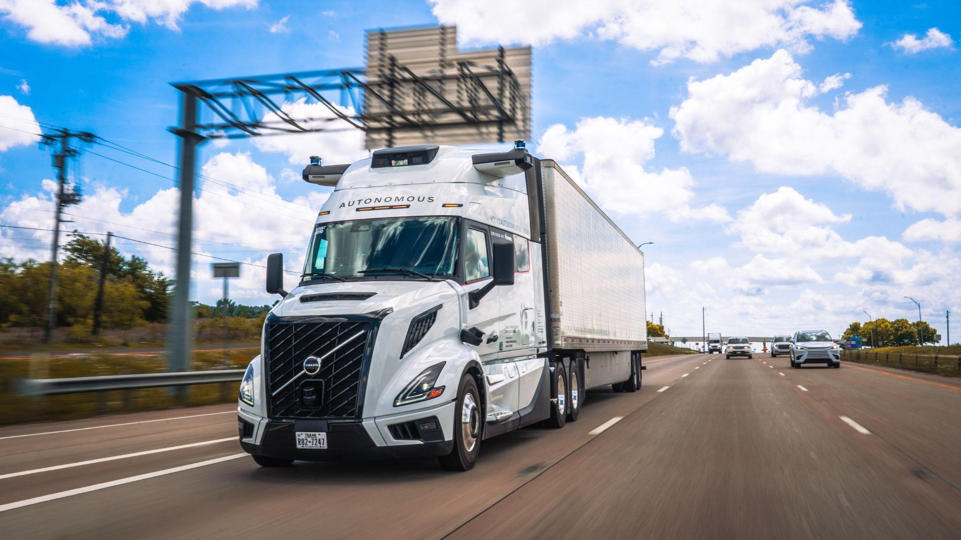
CAPTION: Aurora Innovation, Inc. and Volvo Autonomous Solutions announced the expansion of their autonomous freight network with a new 200-mile route between Dallas and Oklahoma City.
About Volvo Autonomous Solutions
Volvo Autonomous Solutions (V.A.S.) is the business area within the Volvo Group focused on developing and commercializing autonomous transport solutions in selected industry verticals. V.A.S. delivers end-to-end autonomous transport solutions that combine a purpose-built vehicle, a virtual driver, required infrastructure, operations and uptime support, and a fleet management system that orchestrates transport operations and manages logistics flows. Solutions are tailored to each customer’s needs and designed to support safer, more productive and more sustainable operations. Press images and films are available in the Volvo Autonomous Solutions image and film gallery.
About Aurora
Aurora (Nasdaq: AUR) is delivering the benefits of self-driving technology safely, quickly, and broadly to make transportation safer, increasingly accessible, and more reliable and efficient than ever before. The Aurora Driver is a self-driving system designed to operate multiple vehicle types, from freight-hauling trucks to ride-hailing passenger vehicles, and underpins Aurora’s driver as a service product for trucking. Aurora is working with industry leaders across the transportation ecosystem, including AUMOVIO, FedEx, Hirschbach, NVIDIA, PACCAR, Ryder, Schneider, Toyota, Uber, Uber Freight, Volvo Trucks, Volvo Autonomous Solutions, and Werner. To learn more, visit aurora.tech.
Cautionary Statement Regarding Forward-Looking Statements
This press release contains certain forward-looking statements within the meaning of the federal securities laws. All statements contained in this press release that do not relate to matters of historical fact should be considered forward-looking statements, including but not limited to, those statements around our driverless operations and future financial and operating performance; our ability to meet customer demand, reduce costs and general expectations beyond that year; the safety benefits of our technology and product; our ability to achieve certain milestones around, and realize the potential benefits of, the development, manufacturing, scaling and commercialization of the Aurora Driver and related services, on the timeframe we expect or at all; our relationships with our partners and customers and anticipated benefits that they may derive from our product; and the anticipated impact of our product on the freight industry and economy. These statements are based on management’s current assumptions and are neither promises nor guarantees, but involve known and unknown risks, uncertainties and other important factors that may cause our actual results, performance or achievements to be materially different from any future results, performance or achievements expressed or implied by the forward-looking statements. For factors that could cause actual results to differ materially from the forward-looking statements in this press release, please see the risks and uncertainties identified under the heading “Risk Factors” section of Aurora Innovation, Inc.’s (“Aurora”) Annual Report on Form 10-K for the year ended December 31, 2025, filed with the U.S. Securities and Exchange Commission (the “SEC”) on February 11, 2026, and other documents filed by Aurora from time to time with the SEC, which are accessible on the SEC website at www.sec.gov. Additional information will also be set forth in our Quarterly Report on Form 10-Q for the quarter ended March 31, 2026. All forward-looking statements reflect our beliefs and assumptions only as of the date of this press release. Aurora undertakes no obligation to update forward-looking statements to reflect future events or circumstances.
Press Contacts
Ceren Wende
Head of Marketing and Communication, Volvo Autonomous Solutions
Mobile: + 46 31 322 4536
Email: ceren.wende@volvo.com

Rachel Chibidakis
Head of Partner and Product Communications, Aurora
Mobile: 415-314-9392
Email: rchibidakis@aurora.tech

######

