P R E S S R E L E A S E
Volvo Trucks previews the next step in electric trucking for North America

A new electric truck is coming—and it is built on Volvo’s proven performance and real-world experience

Volvo Trucks North America is previewing the next-generation Volvo VNL Electric, a new battery-electric truck in development, designed for regional haul, drayage and city distribution. As the fourth truck planned for Volvo’s new platform—alongside the all-new Volvo VNL, the all-new Volvo VNR, and a recently previewed future vocational model—the VNL Electric represents the next step in Volvo’s long-term electrification strategy. The updated platform is designed to support all future technologies, including battery-electric, fuel cell and internal combustion engines.

Built on real-world experience
Developed for the segments leading the transition to zero-tailpipe emission transport, the Volvo VNL Electric reflects Volvo’s more than seven years of experience delivering battery-electric trucks to customers around the world. The company’s approach focuses on applying electric solutions where they deliver the greatest impact today—supported by real-world operational data and a growing ecosystem of infrastructure, service and support.

Globally, Volvo Trucks continues to advance battery-electric technology, developing new truck platforms with increased range, improved performance and greater application flexibility. This ongoing innovation builds on Volvo’s real-world global experience and helps inform future electric solutions for the North American market, including the Volvo VNL Electric.

“Volvo Trucks has been delivering battery-electric trucks to customers for several years, giving us valuable real-world insight into how these vehicles perform across different applications,” said Peter Voorhoeve, president, Volvo Trucks North America. “The Volvo VNL Electric will build on that experience, designed specifically for the segments where electrification is gaining the most momentum, and supported by an ecosystem that helps customers operate with confidence.”

As part of Volvo’s flagship VNL family, the VNL Electric will deliver the same high standards of comfort, connectivity and safety that drivers and fleets expect, now in a zero-tailpipe emission configuration. The truck will be equipped with Proterra’s Onyx Battery Platform, with industry leading safety, durability and proven performance in the most challenging operating conditions. Proterra’s batteries are manufactured in the United States at the company’s factory in South Carolina, supporting both performance and supply chain reliability.

An ecosystem ready to support scale
Today, Volvo Trucks has more than 750 battery-electric trucks operating across the United States and Canada, collectively logging over 30 million zero-tailpipe emission miles. These deployments are supported by a growing network of Volvo Trucks Certified EV Dealerships, providing the expertise and infrastructure needed to help fleets successfully transition to electric transport.

Volvo Trucks has certified 84 dealer locations across 33 states: Alabama, Arizona, California, Colorado, Delaware, Florida, Georgia, Idaho, Illinois, Indiana, Louisiana, Maine, Maryland, Massachusetts, Michigan, Minnesota, Missouri, Montana, Nevada, New Jersey, New York, North Carolina, Ohio, Oklahoma, Oregon, Pennsylvania, Rhode Island, Tennessee, Texas, Utah, Virginia, Washington, and Wisconsin and four Canadian provinces: British Columbia, Manitoba, Ontario, and Quebec.

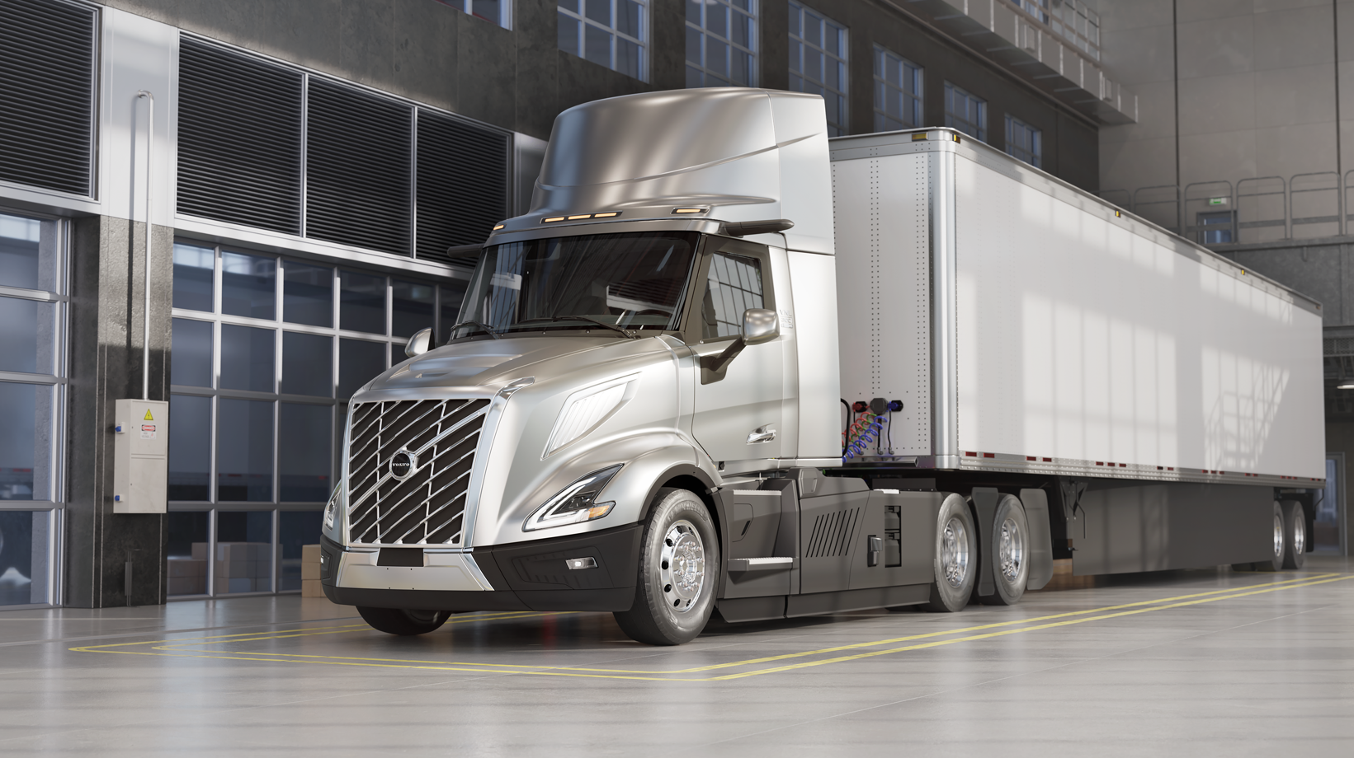
CAPTION: Volvo Trucks North America is previewing the next-generation Volvo VNL Electric, a new battery-electric truck in development, designed for regional haul, drayage and city distribution.

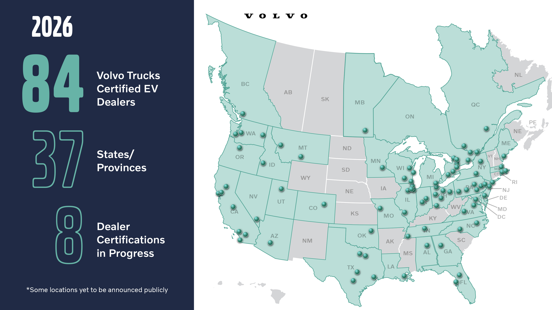

CAPTION: Volvo’s battery-electric trucks are supported by a growing network of Volvo Trucks Certified EV Dealerships, providing the expertise and infrastructure needed to help fleets successfully transition to electric transport.

May 4, 2026

To learn more about Volvo Trucks North America and the Volvo VNR Electric, visit the company website.

High-resolution images associated with this press release and others are available at https://press.volvotrucks.us/.

For further information, please contact:

Allison Scudder
Public Relations Manager
336.833.4679
allison.scudder@volvo.com

Volvo Trucks North America, headquartered in Greensboro, North Carolina, is one of the leading heavy-duty truck manufacturers in North America. Its Uptime Services commitment is delivered by a network of nearly 400 authorized dealers across North America and the 24/7 Volvo Trucks Uptime Center. Every Volvo truck is assembled in the Volvo Trucks New River Valley manufacturing facility in Dublin, Virginia, which meets the internationally recognized ISO 9001 standard for quality, 14001 standard for environmental care and holds a dual ISO 50001/Superior Energy Performance certification at the platinum level, indicating a sustained excellence in energy management. Volvo Trucks North America provides complete transport solutions for its customers, offering a full range of diesel, alternative-fuel and all-electric vehicles, and is part of the Volvo Trucks global organization.

Volvo Trucks supplies complete transport solutions for discerning professional customers with its full range of medium- and heavy-duty trucks. Customer support is provided via a global network of dealers with 2,200 service points in about 130 countries. Volvo trucks are assembled in 12 countries across the globe. In 2025 approximately 120,000 Volvo trucks were delivered worldwide. Volvo Trucks is part of the Volvo Group, one of the world’s leading manufacturers of trucks, buses, construction equipment and marine and industrial engines. The group also provides complete solutions for financing and service. Volvo Trucks’ work is based on the core values of quality, safety and environmental care.

About Proterra
Owned by the Volvo Group and independently operated as a standalone company, Proterra is the proven electrification partner for heavy-duty transportation and equipment manufacturers enabling the shift to zero-emission products. By providing innovative battery solutions that perform in the toughest environments, Proterra empowers their customers to build a safe and sustainable future. Learn more at proterra.com.

